 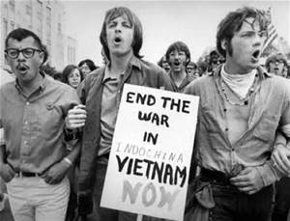

By: Teri

P.O.W.E.R. P

Power p is the process of writing just about anything. The letters to this word stand for: plan, organize, write, edit, revise, and publish. It is a short and quick way to remember the writing process steps. One reason why I like it is because if you follow these steps I believe you will most likely get a good review/grade on whatever you wrote. Power p also goes with things such as creative writing skills and creative thinking. Even though we learned a lot this year something that stuck out to me included this awesomely accurate acronym.

GT Winter Newsletter

Romanticism was a movement during the 18th and 19th century that was literature, philosophy, art, religion, and politics. We talked a little about romanticism in G.T. during October when we were learning about creativity through the study of great authors like: Mary Shelley, Edgar Allan Poe, Roald Dahl, and Charles Dickens. Romanticism was popular in Europe, United States, and Latin America. Famous romanticism authors were Edgar Allan Poe, Mary Shelley, Emily Dickinson, and William Wordsworth.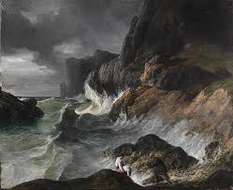

**Romanticism**

      By Amare

6th grade GT

Week of Jan. 12th, 2015

Trumann Gifted and Talented Program grades 3-12

What do you know about the Vietnam War? What I have learned about the Vietnam War is that the United States first combat was in August 5, 1964. When there were air strikes during the Gulf of Tonkin incident. I learned in GT that the Vietnam War was going on in the 70’s and that the Vietnam War ended in 1974. The reason why I choose this topic because my grandpa was in the Vietnam War and I love to talk to him about but some people who were in the Vietnam War.

**Seatbelts in the 70’s**

**By Hannah**

   Seatbelts are saving people's lives from when they were put in till now. Every minute one or several people die from not wearing seatbelts. People should wear them every day.  They were put in cars for a reason. It is almost 9 times safer to wear your seatbelt than to not put it on.

 The seatbelts were installed in manufacturers cars in the 1950’s. They weren’t later on installed in our cars in the late 1970’s and early 1980’s. The first state to pass the seatbelt law, which you were required to wear your seatbelt, it was made December 1st, 1984.

The Safe Water Drinking Act

By Jordan

A couple weeks ago we studied the Safe Water Drinking Act. The Safe Drinking Water Act is the main federal law that ensures the quality of Americans drinking water. The law was passed in 1974 to protect public health.

The Vietnam War by Jacie

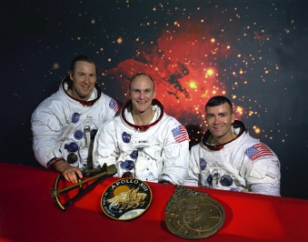

Roald Dahl By: Caera

In the GT program we learned about Roald Dahl and we read one of his very interesting books. It was called “ The Great Mouse Plot” and it was a very good book. We learned many things about him he wrote more books such as “Twits” or “ Charlie and the Chocolate Factory” and many, many more. He was a very talented and funny author and this is the whole reason why I picked this author because he has such an imagination and creativity!! The GT program has taught me so many more great author such as Mary Shelly or Charles dickens that have big imaginations and I hope to be just like Roald Dahl someday in my life.

Nam quis urna bibendum tortor pretium iaculis. Nullam cursus. Donec erat. Sed lorem. Nullam tortor. Nam mollis diam sit amet ante sodales placerat.

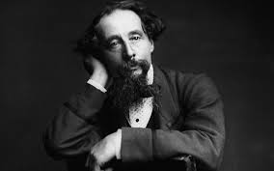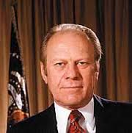

# Apollo 13

Charles Dickens By Journey

We’ve learned a lot in this school year, but what I liked was learning about Charles Dickens. I liked reading *A Madman’s Manuscript.* He wrote several different books like *Oliver Twist* and *A Christmas Carol!* Dickens had a pretty bad life, but his books were amazing. To a lot of people he has a very vivid imagination. His book characters are very interesting. He had to put a lot of thinking into the characters and the books themselves! He was a great man and author.

By Katie

On September 22, 1975, at 3:30 pm, Ford got another gun pointed at his head while he is leaving saint Francis hotel. The one with the gun was Sarah Jane Moore. This only came 17 days after the first try by another women. She tried to kill him on his way to a speech in California. One shot missed and a bystander deflected the other when they pulled their arm down. He saved Fords life that day because the shooter had a clean shot at Ford. Then the police around the car and FBI had time to stop the shooter and put her in jail.

I chose this topic because I have a love for looking up cool things. So when I heard that Mr. Ford lived through two assassination attempts in the same month, I was like Oh my!!



#### The Two Attempted Assassinations of President Gerald Ford

The Apollo 13 mission occurred on April 11, 1970. According to the Air and Space Museum Website, it was the first aborted Apollo space mission. Their website also said that “splashdown was on April 17th 1970 and that the entire duration of the mission from blastoff to splashdown was: 142 hours, 54 minutes and 41 seconds.”

Of course the Apollo 13 was bound for the moon but complications occurred, damage to their spacecraft (Aquarius) was incurred as they left Earths Atmosphere. This damage was significant enough they had to abort the mission. They still had to circle the moon so they could slingshot back into Earths gravitational pull. They had to do many calculations to know how much oxygen and energy they had remaining in their fuel cells so they could ration it so their would be enough to re-enter Earths atmosphere. According to Space.com, this mission demonstrated how very dangerous it is for humans to work in space. Also, in reference to this “near-disaster” mission a wonderful movie re-enacting the events that led up to Apollo 13 as well as the mission itself is depicted in the award-winning movie by the same name. Of course it stars Tom Hanks, Kevin Bacon and many other well-known actors. You should check it out.

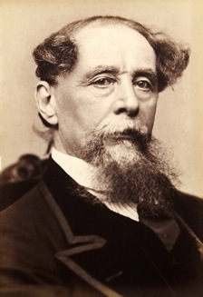

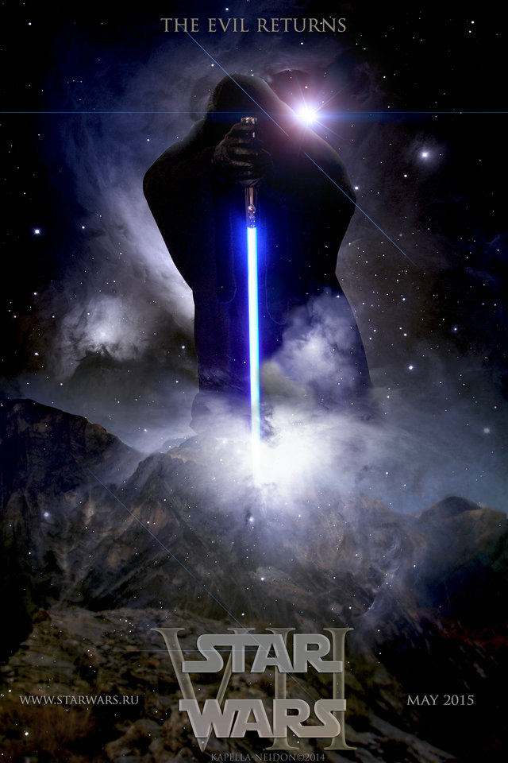

#### Charles Dickens

#### By Mia

The Great Charles Dickens

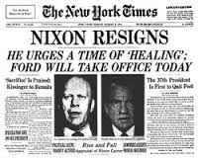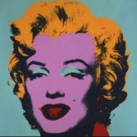

Andy Warhol was a pop artist. He is known for his Campbell soup can and his Marilyn Monroe pop art. He also was the artist of a few paintings that are not as famous as the Campbell soup cans and Marilyn Monroe pop art, like “Eight Elvis’s” and “Race Riot”. Andy was born in Pittsburgh, PA on August 6, 1928 and died in New York City, NY on February 22, 1987. He has a museum in Pittsburgh, PA (his hometown) just for his artwork. The museum opened on May 15, 1994. Warhol was the man that started the art trend, POP art. Andy was also a filmmaker. He directed movies such as Chelsea Girls, Flesh, Empire, Trash and lots more. It’s safe to say that Andy Warhol was a great artist and a well-known filmmaker with many films made in the 60’s and 70’s.

**Watergate by Garner**

    Watergate was a scandal that President Nixon used so that he would get elected. It was illegal and very wrong. Nobody knew about the Watergate scandal at the time. Nixon had people listen to the phone calls of the other party and spy on their headquarters. President Nixon won but was almost impeached but resigned before he was. Gerald Ford then became president.



**Andy Warhol and Pop Art**

By Kaylee

I learned a lot about Charles Dickens in October in G.T. class. I really enjoyed learning about Charles Dickens! Charles Dickens was born on February 7,1812. He was born in Landport. He wrote one of the most famous Christmas stories on the planet, a Christmas Carol! He also wrote children and adult books of all kind. Some more of his most popular books include A Tale of Two Cities, The Pickwick Papers, Great Expectations, and Oliver Twist. He later moved to Higham, United Kingdom to pursue his dreams in writing. Although, he wrote many different genres, he was really proficient in gothic and horror genres. A few of his most horrific books include A Mad Man’s Manuscript (which we read in GT), The Baron of Grogzwig, and even A Christmas Carol. He died June 9, 1870. Overall, Charles Dickens was an amazing writer and his legend will live through generations and generations!

**Star Wars**

**By London**

Star Wars made a big bang in the 70’s. Personally, my favorite character is Chewbacca, the big, furry creature native to the planet of Kashyyyk. This movie is science fiction, and has a very galactic story behind it. Star Wars really interests me, and Princess Leia, You don’t need a man to save you! Yoda and Darth Vader are some other favorites of mine. May the force be with you, ciao’!



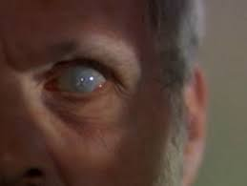

New Learning Styles

    I mostly enjoyed the day of G.T. when we learned about the learning styles. We got to take a quiz to see if we were visual, logical, aural, verbal, physical, solitary, or social. I am going to go ahead and tell you that I am definitely not social. What I got on the quiz was visual. I most definitely prefer seeing things rather than hearing things. I’m not very imaginative, though I can write creative stories. The meaning of the word visual is whenever you see something with your sight. - Kay Kay

# **Edgar Allen Poe**

# **By Maddox**

# **Ed was a gothic writer who wrote *The Tale-Tell Heart*, *The Black Cat*, and many others. He was born in Boston on 1809 and died in Baltimore on the year 1849. His books where scary for his time era and I think they are still scary now. He does not only write books he also writes short stories. He was one of the various writers we have talked about in the GT program.**

**The Beatles Break-Up**

**By: Zoey 5th Grade**

The Beatles Last Album Recorded was “Abbey Road” but not the last to be released, was “Let It Be”. On April 10th, 1970 The Beatles announced that they were breaking up. Now I think that the world was in chaos because this band was so loved by everyone in the world. When The Beatles were together the world was still in chaos because of ‘Beatle mania’ if you don’t know what that is it’s basically how people went crazy for this band. Now I myself am obsessed with The Beatles but I wouldn't scream and cry if I saw them (Okay that’s a lie I totally would.) So I imagine that when The Beatles broke up the world was in panic that’s how much people loved this band. Sadly only two members of The Beatles are still alive today those two are Ringo Starr and Paul McCartney. John Lennon died on December 8th, 1980 because of being assassinated and George Harrison died on November 29, 2001 because of cancer. But The Beatles were an amazing band and their music will be loved forever.

**Creativity**  & Learning Styles

By Trenton

In GT we studied cool stuff, but I enjoyed creativity the most. Did you know there are six types of creativity? The six types are Elaboration, Flexible, Originality, Fluent, Imaginative, and Divergent. Divergent is my favorite because I can use my mind in a fun way.

    Creativity isn’t the only thing I am going to talk about. In GT we took a quiz that would tell us our learning style. There are three types of learning styles. There are Visual, Auditory, and Tactile. You could also be two of them at the same time, or even all three of them. I learned I am a visual learner.

    I chose these topics because I really enjoyed it. I learned how to become more creative and what learning style I have. I hope you enjoyed.

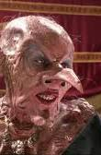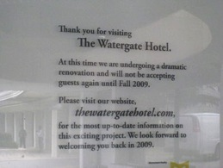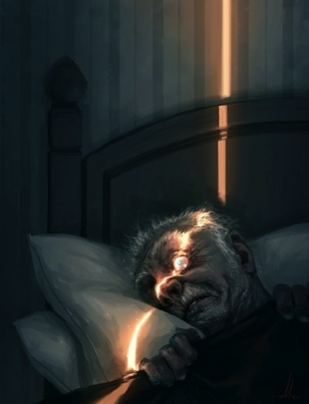

The Witches by Roald Dahl

By Carlie

The Witches is a recent book I’ve read. It inspired me to stand up for yourself, bring bad people in the world down, and if someone turns you into a mouse, get revenge. (Ha, did you see what I did there?) The Witches is a children’s book written by Roald Dahl, a Norwegian author. The grandma is Norwegian because of him being Norwegian.

Nixon a Liar or Not

By: Hunter

## Today I’m going to talk about Nixon and Watergate scandal. The Watergate scandal is where Nixon spied on the democrats and then he resigned so he would not be the first person to be impeached. After Nixon was found out Ford became president because he was the vice president. To me it means that nobody is immune to the laws of the United States of America.

## Thank you for reading.

Fear “THE VULTURE EYE”

The Tell Tale Heart by Anna

The Tell Tale Heart was a short story published in 1843 by Edgar Allan Poe in January. It is very deep, scary, and serious. I liked when he was talking about the vulture eye. Edgar Allan Poe was so detailed and very creative when he wrote this short story. The way that he described everything it made me tingle and shake. I was so nervous, scared, and eager to find out what he was goanna do cause he was furious. This is my favorite topic so far because it was just an amazing, breath taking, and the scariest short story I have ever read.

The Tell Tale Heart

By: Haile

The Tell Tale Heart written by Edgar Allen Poe in 1843 is a gothic type story about a man try to rid his employer because of one his flaws… his one damaged eye or his vulture eye. I personally think that this story can give anyone goose bumps as it talks about the vulture eye with no emotion or feeling, just coldness and blackness staring at nothing but air. It makes goose bumps appear when the narrator describes the beating of his employer’s heart through the floorboards though no one but him seems to hear it, but him. I recommend this creepy tale to anyone who wants to read a frightful story or a literary masterpiece.

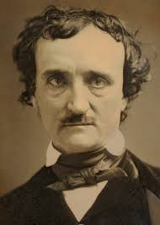

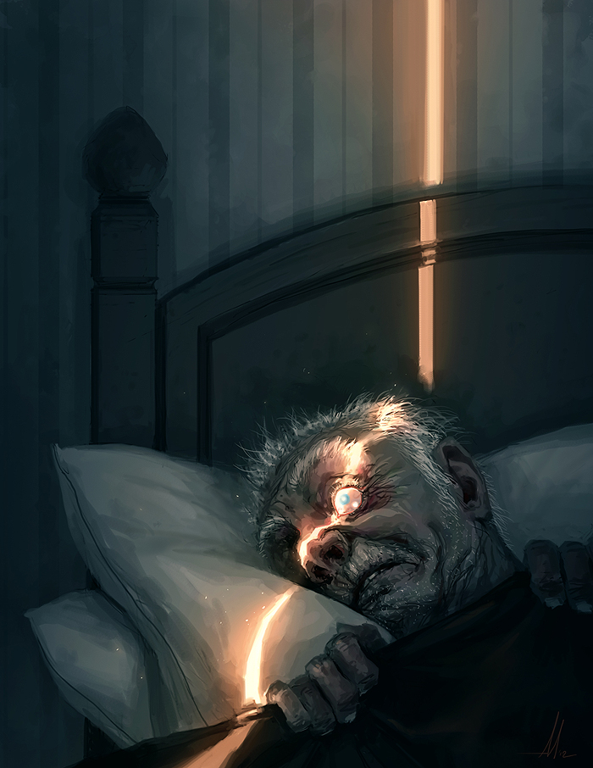



I am very interested in interviewing a person about the 70’s. I am interested in the interviewing a person for the 70’s because I think it will be a really fun and interesting process for me and whomever watches it, I also want to do it because I think it will give me a little practice for being on camera for my dream job of being an actress. I have already found whom I am going to interview and I am very excited to see what he has to say. I am going to interview my Introduction to business communications and technology, Mr. Merriweather. I have also found out what I am going to ask him and I have five great questions that I think he will answer with great enthusiasm. I will list my five questions below. I am just at the beginning of my process for my interview but I fully intend to have it done by next week.

  Questions:

1. How old were you in the 70’s?
2. How do you think the 70’s changed your life?
3. How did you feel about the Vietnam War going on in your life?
4. How did the Vietnam War affect your life if it did how?
5. What are some things that are different in our world now than in the 70’s?

The Interview Process!!!

By, Breann

Edgar Allan Poe

By: Mycha

I was very interested in doing a research paper on Edgar Allen Poe and the reason why I chose him is because during G.T. class when we first read his story, “The Tell Tale Heart”, I thought it was quite interesting about how he wrote that a man killed his master just because of his vulture eye, and just the way he wrote and described everything.  Edgar Allan Poe was also the author of, “The Raven”. Poe was born on January 19, 1809 in Boston, Massachusetts. He wrote tales of mystery and horror, which is sort of like the modern detective stories. Poe never really knew his family, his father left him and his mother, and then she died when he was three so he then went to live with John and Frances Poe who were successful tobacco merchants in Richmond, Virginia.

On October 7, 1849 Edgar Allan Poe was found at Gunner’s Hall, which was a public house on 44 East Lombard Street, and was taken to the hospital. He was going in and out of consciousness and was never quite able to tell what happened.

The 70’s Sports

BY: Jose

The 70’s sports was my favorite topic we learned in GT this year. Sports: such as football, soccer, basketball, etc. was very famous, but soccer was the sport i liked the best. My favorite player that played in the 70’s was Pele. His full name was actually Edison Arantes do Nascimento. He was born in October 23, 1940. He played for Brazil, and To this day he is still one of the best soccer player of all time. This was my favorite/player of the 70’s.

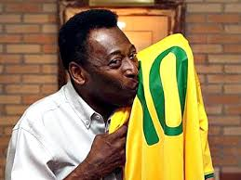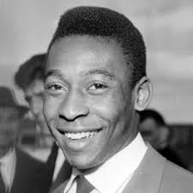

**Creativity**

By: Aejarah

     In GT, we have learned about a variety of subjects such as science, literacy, art, and history.

We have acquired this knowledge from our remarkable teacher, Ms. Stevens and even our fellow GT students. I was most enthralled with learning about creativity. Creativity is the essence of imagination. When it comes to creativity, there are no rules. When using creativity with a great deal of concentration, the only obstacle in your path is a limitation of your own imagination. There are six faces of creativity. The first of the unfamiliar faces is originality. Originality means that it’s unique. It could also mean that you, yourself are completely capable of thinking in an independent and creative way. The significant second of the faces is curiosity. This means that you are determined to learn or discover new knowledge. The terrific third face is known as flexible thinking. When you are thinking flexibly, you are able to be resourceful and find creative solutions to your problems. For instance, if you are having trouble studying for a test, you could write your facts down using colorful crayons, multicolored pencils, or even a vivid variety of markers. That way, you will be able to remember them if they are surrounded by your favorite colors. The fascinating fourth face of creativity is imagination. When you use imagination, you will have the ability to create anything that comes to your mind, as long as you are determined to do it. The flawless fifth face of creativity is elaboration. Elaboration is the ability to add extra texture or details into your work. The final of the faces of creativity is known as divergence. Divergent means to be different or unique. Creativity itself is described as divergent. Despite what you would believe, creativity is all around you. I would prefer to think of creativity as a doorway into your imagination. It would become an inspiration for a number of things. Creativity is even a type of art. You can use creativity to design a dress, draw a picture, or even trying to unlock a door without a key. Everyone has a creative side in them somewhere. They just have to reach deep down, and find it.



**Theodor Seuss Geisel better known as Dr. Seuss! By Halylee**

I chose to write about Dr. Seuss because he is one of my favorite authors for children and we’ve read his biography in GT (since he was still alive during the 70’s and we are studying that decade).  Another reason I chose to write about Dr. Seuss is because many of my favorite books were written by that Dr. Seuss. Is Books like “The Cat in The Hat,” and “Green Eggs and Ham.” His first book was “And To Think That I Saw It On Mulberry Street” in 1937. Ever since then he has been a renowned children's author.

By: Haylee

OSHA (Occupational Safety and Health Administration)

By: Adrian

You might be wondering what is OSHA? OSHA is an acronym for Occupational Safety and Health Administration. OSHA was founded in 1970. The reason OSHA was put into act is because too many people at their jobs were getting injured and sometimes killed, so that is why OSHA was created. But who made OSHA? Richard Nixon signed the OSHA Program into law. OSHA prevents injuries, deaths, and illness on the job. OSHA regulations are Maintain conditions and/or adopt practices necessary and appropriate to protect workers on the job, be familiar with and comply with standards applicable to their establishments, ensure that employees have and use personal protective equipment when required for safety and health. I hope that you enjoyed my paragraph about OSHA and I hope that you have learned something from it.



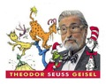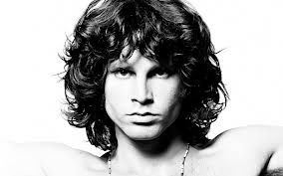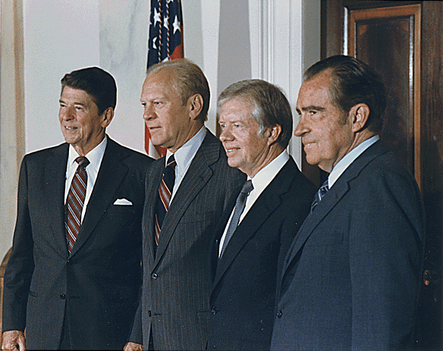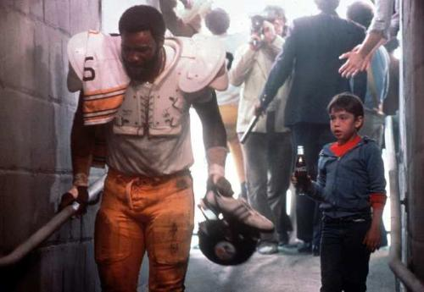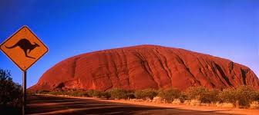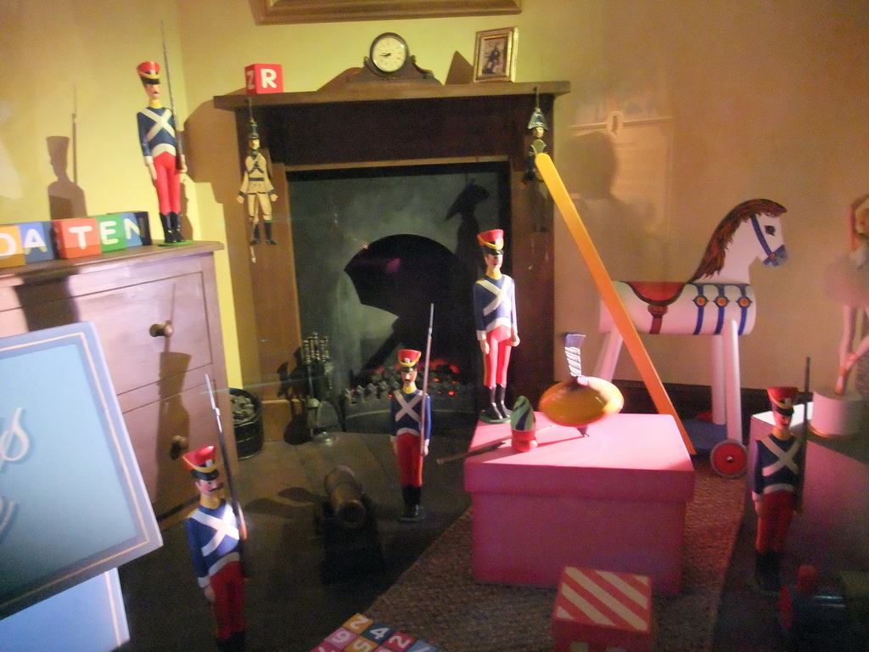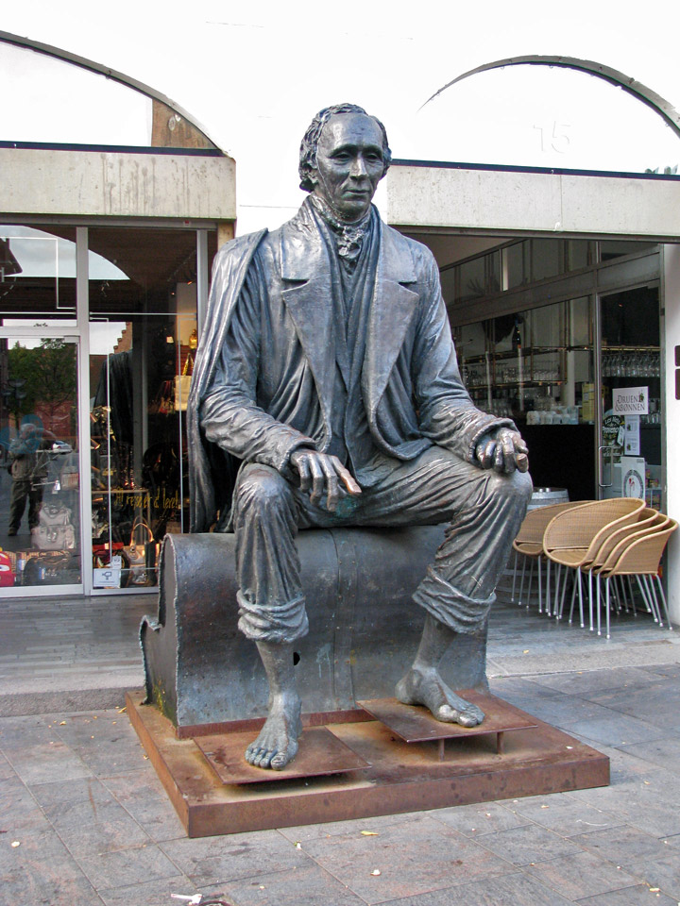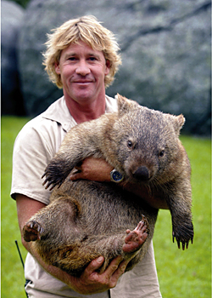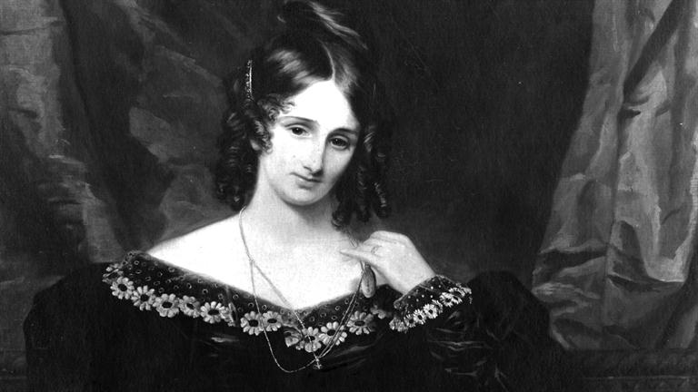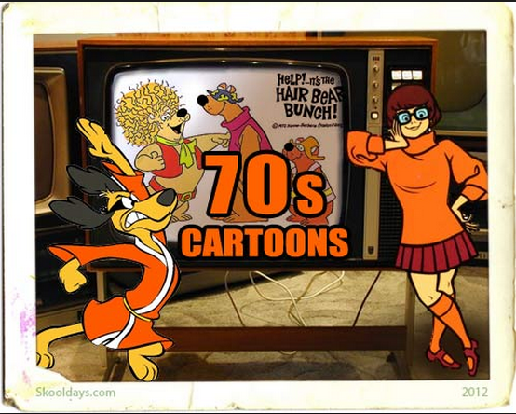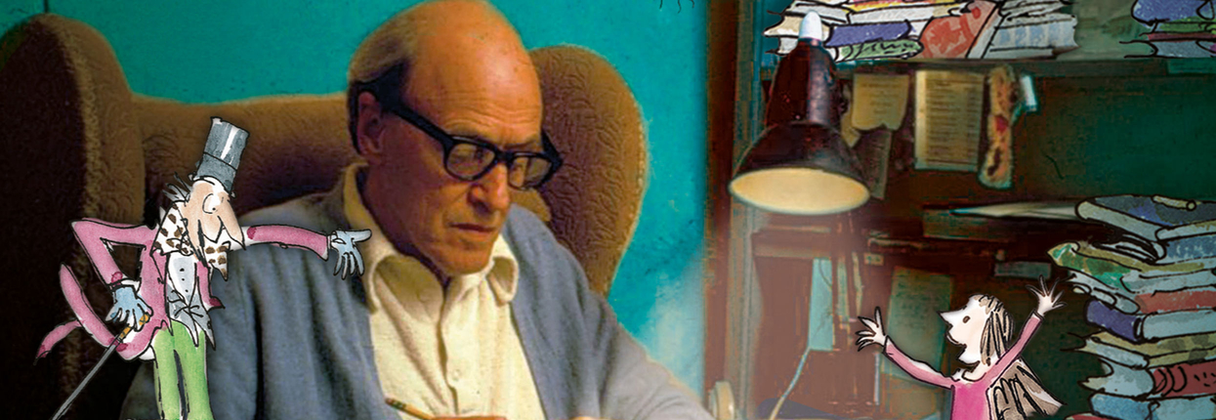

**The Safe Water Drinking Act of 1974**

We have learned a lot of interesting information in G.T. this year, but above all I enjoyed researching the SDWA or Safe Drinking Water Act. The Safe Drinking Water Act was an act passed by congress in 1974. Its goal was to protect public health by regulating the nation's drinking water supply. It is the main federal law that ensures the quality of America's drinking water. It is still going on today and it is a tremendous help for the entire nation.

By Logan

Watergate

By: Jonah

Watergate took place at the Watergate hotel on June 17, 1972. When the current president Nixon wanted to get ahead of the democrats to win the next election, he sent people into the Watergate hotel (where the democrats were renting office space) and they were caught in action in the hotel. The phone recordings from the White house were evidence that Nixon knew all about it and was involved all along. So these phone records caught Nixon. They were probably going to impeach him so he just resigned. I chose this because we learned about it in GT and it was a scandal by the president of the United States and to me it was pretty much for nothing.

**Poe By: Kaleb** 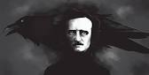

This year I learned about Edgar Allan Poe and the books he wrote and we read a specific one called The Tell Tale Heart. We watched the movie that goes with the book. We also read the Raven. When I first heard of Edgar Allan Poe, I thought who is Edgar Allan Poe? Then I looked him up and I was surprised that I had never read a book by him before. Obviously I enjoy Gothic Horror so this is what interests me in his writing.

**Grease the Movie**

**By: Carson**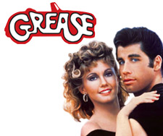

I chose to write about Grease because in GT we have already studied cultural elements such as movies from the 70’s. I chose to write about Grease the movie because I think that this topic (movies) is a good topic for me because I love being entertained. Grease the movie was filmed in 1978 and two of the main characters in Grease are Olivia Newton John (Sandy), and John Travolta (Danny). Before they started filming this movie Olivia Newton John and John Travolta didn't have the parts as Sandy and Danny the only reason they has these parts are because both the actor and actress that originally had the part as Sandy and Danny backed out and then Olivia and John took their place. If you want to know more about Grease the Movie go to <http://www.news.com.au/entertainment/movies/things-you-didnt-know-about-the-film-grease/story-e6frfmvr-1226847851166> for fun and interesting facts about Grease the Movie.

**The First landing on the moon, Apollo 11**

**By: Jackson**

I chose to do the first moon landing because I am a history and science fanatic, so this fits me perfectly. On May 25, 1961 President John F. Kennedy announced that he wanted to put a man on the moon before the end of the decade. President Kennedy was tragically assassinated in 1963, and did not get to live to see his legacy. On July 21, 1969 2:56 UTC (Coordinated Universal Time) Neil Armstrong stepped onto the moon, spending about 2.5 hours outside of the spacecraft, Buzz Aldrin stepped out slightly later, together they collected 47.5 pounds of lunar material. On July 24, the astronauts returned home, this was a relief to the workers at NASA and the astronaut’s families. This ended the Space Race and now the USA has the title of being the First Country on the moon! 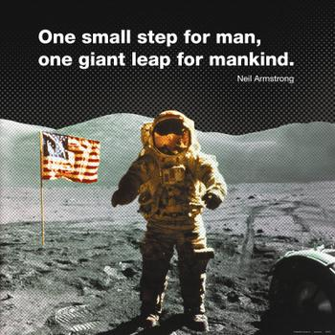

                                                     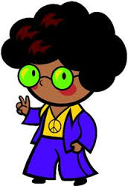

In GT this year we have discussed many topics about the seventies. Fashion is one of the topics we’ve talked about and one that has really grabbed my attention. The fashion of the seventies was very “trippy” as they said. The styles of this time consisted of bell-bottoms, platform shoes, and zigzag patterns that are also known as chevron. Not to mention the wide cut shirts for men! Fashion not only allowed you to look good it also allowed you to do the everyday things you did. Fashion is always evolving and changing so closer to the end of the 70’s fashion was sleeker, shinier and more professional. Just looking at seventies fashion you can tell life was fun!

~Lauren :)

Safe Drinking Water Act

By Cierra

**A couple weeks back my group studied The Safe Drinking Water Act. The Safe Drinking Water Act is an act that makes sure that all water is safe to drink. Congress passed the Safe Drinking Water Act back in 1974.**

**Theodor Seuss Geisel By: Daly**

One of the topics I really enjoyed discussing was the life of Theodor Seuss Geisel {aka Dr. Seuss}. I loved reading Dr. Seuss’s stories when I was a kid. They were all creatively written to teach kids a lesson without them even realizing it. One of Dr. Seuss’s most famous books, *The Lorax*, was published in 1971. One of Dr. Seuss’s reasons for writing *The Lorax* was to raise awareness about the environment and the damage we were doing to our planet. Dr. Seuss was a genius and he was definitely Gifted and Talented, just like us in the GT program. :)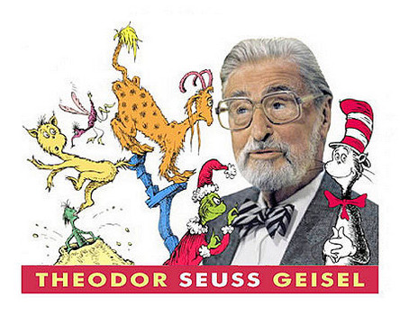

Journey Got Their Start In The 70’s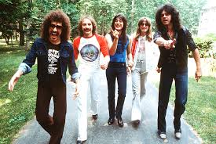

By: Chloe

Hey today we’ll talk about Journey the band from the 70’s so let’s get started.

**So the band Journey has a song by the title of: “Don’t Stop Believing”.** I love this song! They also had several other big hits but this was there biggest! I chose to write about this topic because we’ve been studying the 70’s decade in GT this year.  One cultural element of the 70’s is the music from this era. When we worked on a research project in GT, I discovered that the band Journey began in the 70’s. So, that was a cool discovery for me.

Jim Morrison By: Olivia

Jim Morrison was the lead singer of a 70’s band named The Doors. According to his devoted fans and critics, he was the most influential singers in the world. James Douglas Morrison was born in Melbourne, Florida in December 8th, 1943. Jim moved a lot because of his father occupation. His father was in the Navy. In his young adult life he was arrested for pulling a prank while he was under the influence during a football game. When Jim was 27, he died in Paris, France. He died because of a heroin overdose on July 3rd, 1971.

The reason I chose this topic because Jim Morrison really skyrocketed during the 60’s and 70’s. His fans were really devastated when he past away.



Ralph Nader

By: Jada

        Who was Ralph Nader? Ralph Nader is an auto-safety reformer and consumer advocate. He was born on February 27th, 1934 in Winsted, Connecticut. He has ran for President more than one time but failed all three times. He also convinced that automobile injuries were due to unsafe vehicle designs. Ralph Nader postponed retirement in 2013 and is now currently 80 years old. old.  

Watergate

By: Maddie

This GT year we studied a topic called Watergate. Watergate was a scandal in 1972. This scandal got its name from the Watergate hotel in Washington, DC. Due to President Nixon trying to cover up the scandal and make it seem like it didn’t happen, Nixon resigned in August of 1974. August 1st, a $25,000 check was found in the Watergate burglars bank account. I like Watergate the most out of all we studied, because Nixon was a president that resigned, the ONLY president that has ever resigned, because he assumed that they were going to fire him anyways, so he went ahead and quit.

ATHLETES OF THE 70’S

By: Cole

During the 70’s there were a lot of superior athletes that are now legends. First off one interesting Hall of Famer, 11x time Pro Bowler, and 4x time Super Bowl Champion “Mean” Joe Green. Joe came into the League in 1969 and had a amazing career throughout the 70’s for the Pittsburgh Steelers. Also he is in one of the most noticed Super Bowl commercials of all time  the Coca-Cola Classic commercial. Next is a 19x time NBA All-Star, 6x NBA Champion, and 1970 Rookie of the Year Kareem Abdul-Jabbar. Kareem played for the Milwaukee Bucks and won one Championship in 1971, and he played for the Los Angeles Lakers and won 5x Championships. Even by today’s standards these athletes remain some of the top players in the history of sports.

See picture famous to the left.

Presidents Of The 70’s

By: Kira

There were three presidents in the 1970’s. The first president was President Nixon he resigned in 1974 because of the Watergate scandal. Then President Ford served the rest of Nixon’s term. When he ran for President next year he lost to President Carter. Carter served one term. I am interested in Politics and Legal issues because I want to be a lawyer when I am older. 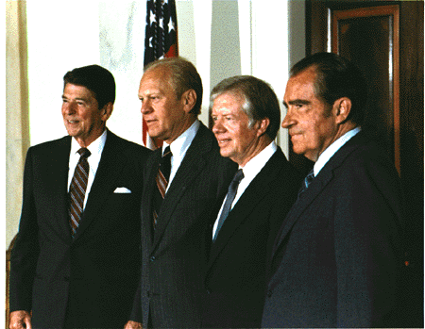

The Fight Between Ralph Nader and G.M.

By: Payton

Have you heard the story of Ralph Nader and G.M’s beef? Well it all started when one of Ralph’s friends was in a traumatic car crash, his friend was paralyzed from the terrible accident. This all got Ralph to thinking, why are there not a safety devices, such as a seat belts available in all cars? He took this idea to congress, which backed him up. Then, when he took his idea to G.M., they ignored him. So congress started to put pressure on G.M. (General Motors). Then GM tried to get some dirt on Ralph Nader. They hired two attractive women to try to seduce him in the grocery store. However their plan backfired when he, being the genius he is, knew that it was a set up. So then that made G.M. look even worse! So then Ralph sued G.M. for $425,000 and won. Also, GM had to publically apologize to Nader.  He is now 79 and fight to aware citizenry on behalf of consumers.

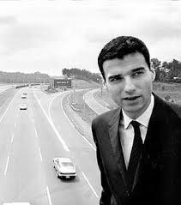

**Australian Animals By Samuel**

**I learned about Australian Animals this year in**

**GT. They include wombats, platypuses’, and dingoes, Kangaroos and more. I liked learning about these animals because they are so different from the animals from America. My favorite animal from Australia is the wild dingo. Dingoes are wild dogs. In the U.S. we have wolves or coyote’s. We’ll in Australia they have dingo’s.**

Ayer’s Rock

By Evan

So far my favorite thing we’ve been studying in GT is Ayer’s Rock.

The reason is because I’ve always thought to myself “what’s that big rock in the background of the photo?” This world famous rock is also is called Uluru. It is made from sandstone.

Hans Christian Anderson By Landon

My favorite thing that I learned in G.T. is about the world famous author Hans Christian Anderson. Anderson is a famous writer from Europe. He wrote:

“The Steadfast Tin Soldier” and “Thumbelina”.

I think he is a great writer.

**Aborigines People**

**By Kaydence**

**This year in G.T. we learned about Aborigines people. Here’s some things we learned about. The word "aboriginal" means "the first" or "earliest known".**

**The aborigines lived in Australia. Australia may well be the home of the world’s first people.** **More than 30,000 years ago the population of the world was small, and people lived in family groups, hunting, fishing and food gathering.** **The first Aboriginals found an Australia with a better environment than today.**

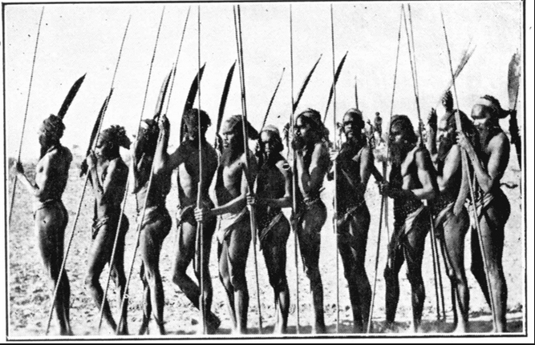

Great Barrier Reef By: MacKenzie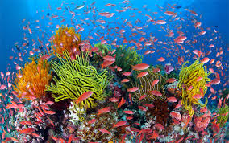

**This year in G.T. we have learned about the Great Barrier Reef. Some things we learned about the Great Barrier Reef are it is in Australia. It is also the largest coral reef on the earth. Another thing about the Great Barrier Reef is, it is one of the Natural Wonders of the world. It is in the North-East of Australia. Some of the plants and animals are coral, anemone, dolphins, whales and clown fish.**

Australian Animals

By: Parks

Australian animals are very weird and cool at the same time. Australian animals like the wombat, the Tasmanian devil and the duck billed platypus are just really fascinating. Australian animals can be very dangerous like the eastern brown snake and the babies are even worse! They have more venom than the adult. Two more dangerous Australian animals: are the Australian funnel wed spider and last but not least the Australian salt-water crocodile.

### *Mary Shelley*

Written by: Madalyn

Mary Shelley is best known for writing the famous science fiction novel Frankenstein published in 1818

during the Romantic Period. The Romantic Period started in the 1800’s and lasted till 1850. The Romantic Period Followed the Enlightenment Period where people had great respect for Science to the extreme. In contrast the Romantic Period was where many intellectuals felt that Science and discovery was important but it wasn’t everything. Romantics both feared and respected nature and felt there were some lines that shouldn’t be crossed. It was also a period when women were not respected as authors, and it was a period of artistic, literary, and intellectual events that originated in Europe toward the end of the 18th century and in most areas was at its peak. Writer Mary Shelley was born on August 30, 1797, in London, England. Mary Shelley found a creative outlet in writing. Mary Shelley didn't have a formal education, but she did make great use of her father's extensive library.

In October we started learning and talking about Mary Shelley. The reason I chose this human to write about is because she amazed me, the way she wrote, such an amazing story! When in her life, it was like she did not even matter because she was a female author. The way her story has changed from its original message is unreal. I am so glad Mrs. Stevens told us the real story! Mary Shelley is just a truly amazing writer.

Cartoons of the 70’s

By Emma

Cartoons were taken very seriously in the 70’s! Some popular cartoons were Scooby Doo, The Flintstones, and Tom and Jerry. They were very popular and they still are! The top Ten cartoons of the 70’s were… Gatchaman, Sealab 2020, Star Trek: The animated series, Super Friends, Space Sentinels, Challenge of Super Friends, Battle of The Planets, Tarzan and the Super 7, Flash Gordon, and Tarzan; lord of the Jungle.  Saturday Mornings was the best time to watch cartoons in the 70’s.

Roald Dahl

                   By Maci

In G.T, we learned about authors, one of the authors was the very famous Roald Dahl. Roald Dahl was born on September 13th Roald’s first paid piece of writing was based on his experiences as a War Pilot. His first full-length story was The Gremlins, he worked on it with Walt Disney!! Then he published my favorite book ever, Charlie in the Chocolate Factory in 1964! He died on November 23rd, 1990 L. He had written many other stories since then, like, The Minpins and You only live Twice. 

Pop art in the 70s’

By Samuel Gunter

        The history of pop art begun in Britain when artist who called himself or herself the Independent Group or IG started painting popular items in odd ways. Pop art didn’t really come to the U.S. until after the 2nd World War and one of the major leaders was Andy Warhol, leading the charge in the USA.

Elizabeth Murray: artists of the 70’s

                                By Caroline M.

Elizabeth Murray was interested in pop and graffiti art. When she would paint, she would use different shapes with different sizes, and bright colors. She was born on September 6, 1940, in Chicago, IL, and grew up there. Elizabeth had always liked the way, in her mind how bright colors and shapes flowed together. She started her actual career as famous artists when she moved to New York. That’s where her art was being recognized big time. A very famous painting she had made was called, “Do the Dance.” To me, all of her paintings were very fascinating and interesting. They were all so different from other paintings!

**Watergate   By Connor**

Watergate was a scam to spy on the democrats. Richard Nixon, the president at the time was aware of this political spying scheme.  Many people in the Republican Party helped him out with it. When Richard Nixon made phone calls and received phone calls, they all were recorded at the time and he was in trouble by the government for setting up a scam at June 17th 1972. The phone calls gave away a great deal of evidence of him scheming to see what the Democratic Party was doing. President Richard Nixon was on the verge of impeachment but just right before he could get impeached he had resigned from being the president of the United States.