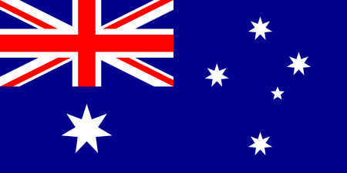

Post Test for Study of Australia (Elem. GT)

Name:_______________________

Date:____________________

1. Where in the world is Australia located?_____________________________________
2. Is the United States larger or smaller than Australia?_________
3. What is Australia’s nick name?_________________________________
4. Does Australia have a queen?__________
5. Do they have a democracy in Australia?_________
6. How many states/territories make up Australia?_______________________
7. What is the city capital of Australia?_________________________
8. Who were the original inhabitances of Australia?___________________________
9. What is the name of the world famous Australian land mark?____________________
10. What famous reef is located along the NE coast of Australia?_________________________________
11. Who claimed this land for Great Britain back in 1770? _______________________
12. What kind of people were the first arrivals after Australia was claimed for Great Britain? __________
13. Name the three of the six animal kingdoms: