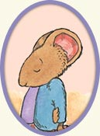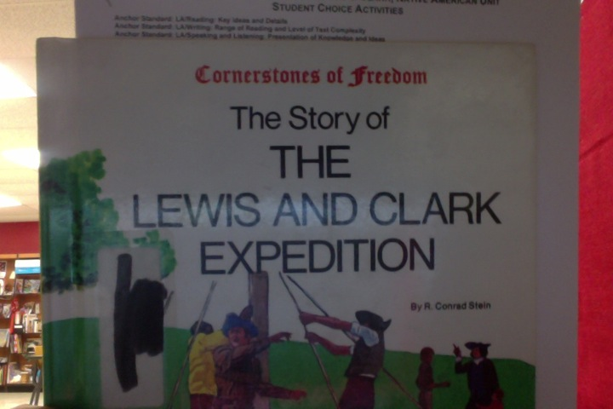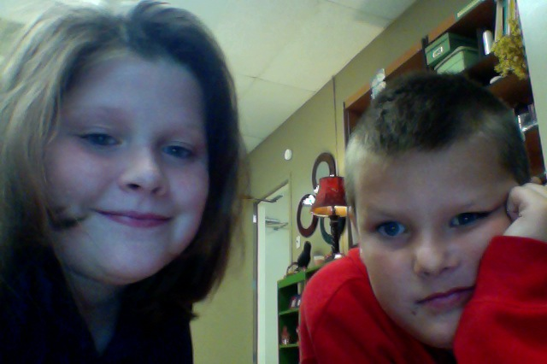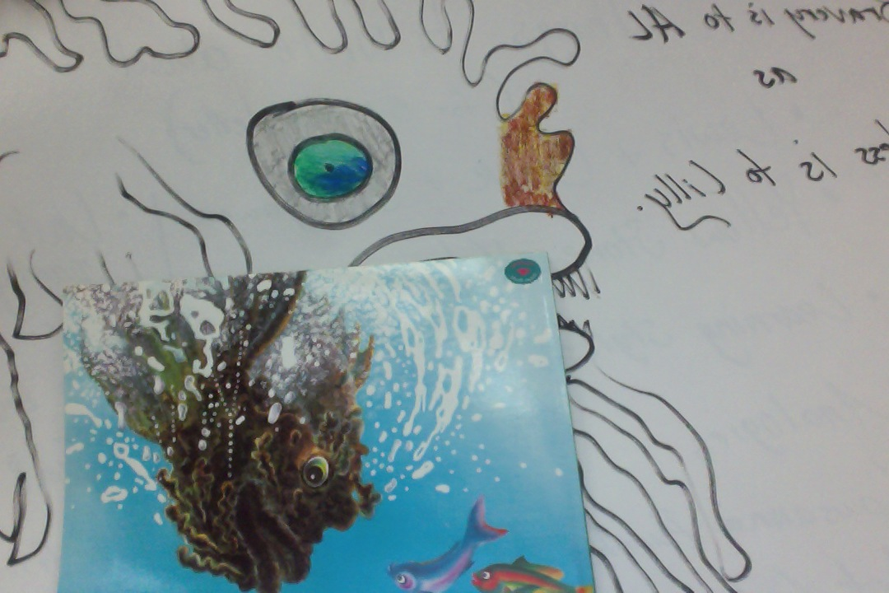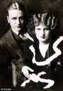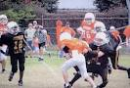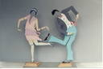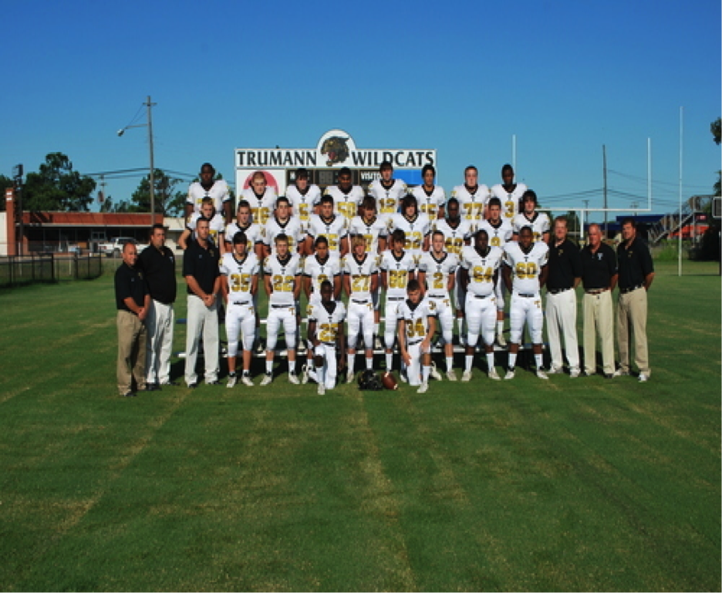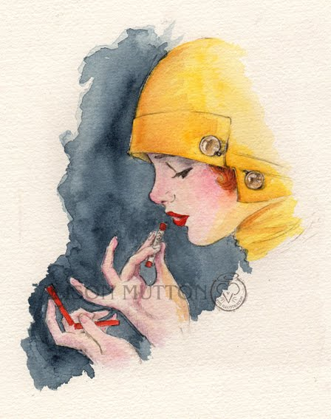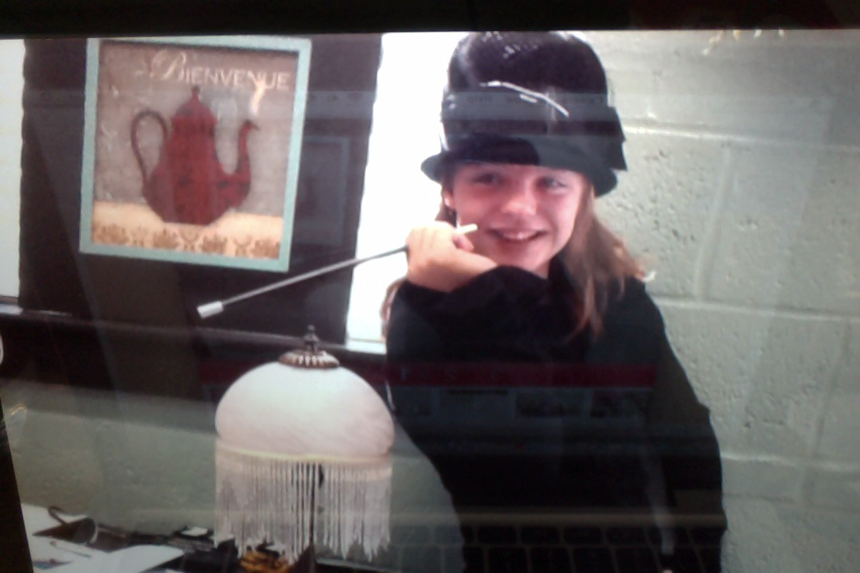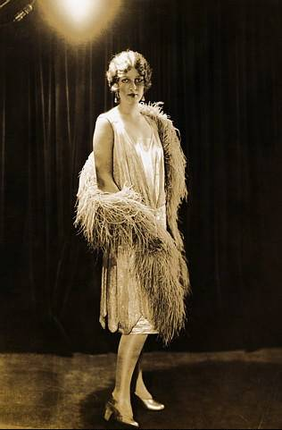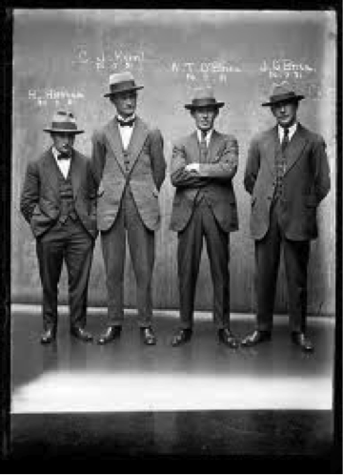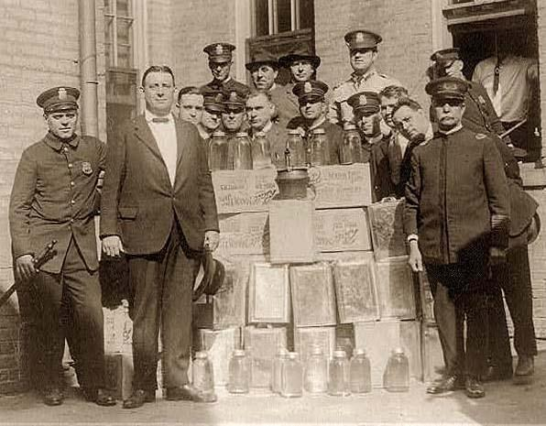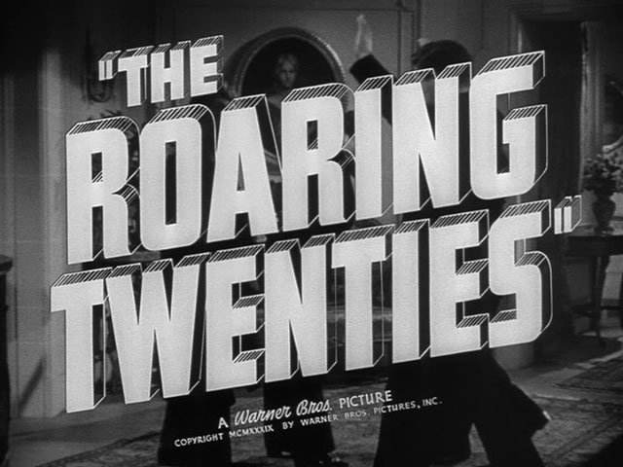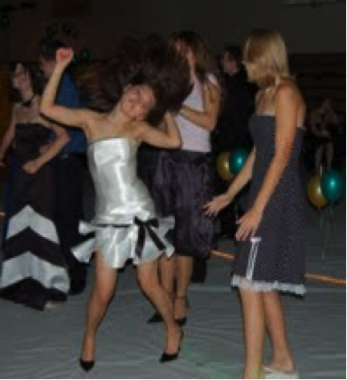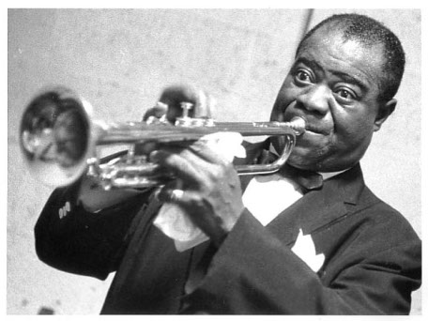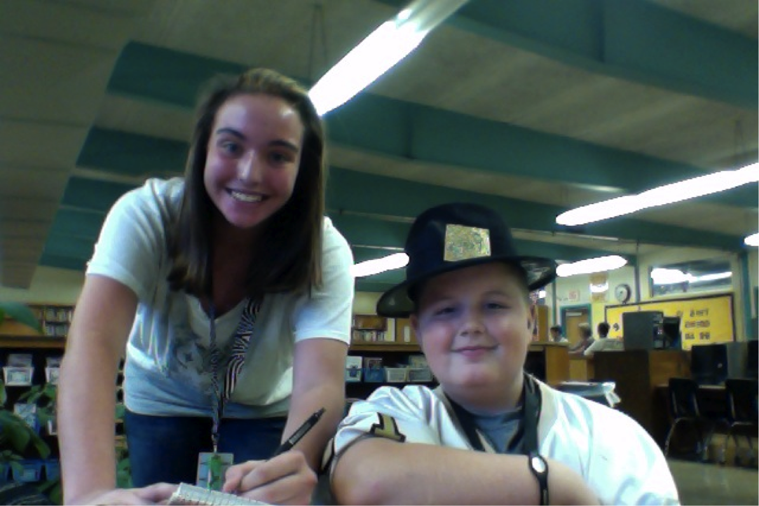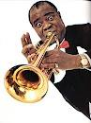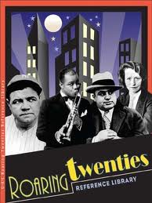

# October News

# Articles written by GT students

**KEVIN HENKES-**

**BY:ISABELLA DAVIS AND ZOEY TAYLOR**

**KEVIN HENKES IS AN AUTHOR OF MANY CHILDRENS BOOKS. HE WRITES ABOUT MICE. KEVIN HENKES SAYS HE ENJOYS BEING IN HIS BIG QUIET OFFICE WRITING, PAINTING AND SKETCHING.**

# We have been learning about learning styles. One learning I know solitary learning. You might know your and that’s good.

# WRITTEN by GARNER HENDERSON AND ETHAN STEWART

##### **Learning Styles**

##### Kevin Henkes

LETS GET PUMPED UP!

**AT THE GT END OF THE YEAR PARTY IN DECEMBER! PLEASE JOIN US AT THE**

**CEDAR PARK ELEMANTRY GT ROOM WE ARE REALLY LOOKING FORWARD TO IT. IT HAS BEEN FUN TO LEARN ABOUT LEWIS AND CLARK BECAUSE THERE LIVES WERE SO AMAZING SOME OF THEM DIED ON THAT ADVENTURE.WE WILL DRESS UP AND PRESENT OUR WORK HOPE YOU ENJOY**

**RAVEN AND LONDON**

#### Looking forward to the Unit Party in December!

Lewis and Clark

In 1803 president Jefferson asked for approval and funding to explore the western part of the continent. This has been fun to learn about! We have enjoyed learning about this cause we get to learn about Lewis and Clark and learning things we didn’t know before is always fun. We didn’t know what we know now.

Written by Drew and Chloe

Lewis and Clark /Native American History Unit Party

Page 1 written and edited by 3rd grade

Page 2 written and edited by 4th grade

Page 3 written and edited by 6th grade

Page 4 written and edited by 5th grade

Page 5 written and edited by 7th grade

Page 6 written and edited by 8th grade

Gifted and Talented Monthly Newsletter

### the

Fall 2012

### Overview

Yellow Stone National Park

YELLOW STONE NATONIAL PARK

Yellow Stone Park is the most fun you will ever have with its guises and volcano. It was America’s first National park. It has the most amazing springs that are actually located in the Geyser Basin. Grand Prismatic Spring is so beautiful. We are including a picture because there are so many magnificent colors in it it’s difficult to describe!

WE WILL HAVE SOME CREEPY CRAWLY DESERTS THAT YOU WILL BE IN DISGUST WHEN YOU SEE THEM. LIKE SOME DELICOUS

WITCHES FINGERS AND FREEZY FROSTY FRAPPICHINO! WE WILL ALSO HAVE A PUMKIN CONTEST WITH WONDERFUL PRIZES FOR ENTRYS OF CUTEST, SCARIEST, WIERDEST AND MOST ORIGANAL. THE HOSTS WILL BE THE CEDAR PARK FORTH GRADE. AND THEY WILL BE INCHARGE OF YOUR DELICOUS DELIGHTS AND THEY WILL SERVE THE FOOD TO WITH YOUR WEIRD DELIGHTS MAKE SURE TO WEAR YOUR WIERDEST COSTUMES AND WE WILL BE SCIENTESTS AND WE ALL HOPE YOU HAVE A WONDERFUL TIME HERE MUAHAHAHA!!!!!!

By Maci, Caera and Mia

**Big AL, character study**

Big Al

Big AL is a book by Andrew Clements. The book is about a fish that looks scary but is not. The fish has no friends but in the end he saves a lot of them and they become good friends.

Louisiana purchase

The Louisiana Purchase made a big part of our country

The Louisiana Purchase had been lots of money.15 million in fact. This purchase was made in 1803.128,ooo sq. miles. France controlled this area from 1699 to 1762.France took back the area in 1800.The U.S got the area three years later. Thomas Jefferson bought the land.

## Lewis and Clark and Sacagawea

Vestibulum eu lacus. Donec velit. Nulla pulvinar ultricies risus. Pellentesque sagittis tristique libero. Nullam hendrerit convallis diam. In vel quam eu augue imperdiet tempor. Maecenas euismod hendrerit metus. Vestibulum scelerisque turpis rutrum turpis. Maecenas sollicitudin arcu sed diam.

# Fall Festival

**Louisiana Purchase**

**Peewee Football**

Written by: Zachary and Taylor

Peewee football is a great sport with fights and speed. The peewee football season has come off to a great start with a 3 and 0 season so far. Finally beating Newport the Peewee football team is pumped up to win the season undefeated. The season this year is hoped to be a good one.

☺Friday Nights Football☺ ☺Game☺

9/14/12

**This was a great game even though we lost☹. The score was 13 to 64...Corey got slammed and cracked three of his ribs!!! Earle had great players but they were rough to beat. The band played great and the cheerleaders were awesome! So were Earle’s. The food was also great! We will hope to see you at the Homecoming game on 9/28/12.They will be vs. Westside!!!!!!!!!!!!!!!!!!!!!!!!!!!!!!!**

**Art Deco of the 1920’s**

By: Olivia Moss and Adri

As grand and elaborate as wallpaper was in the Victorian Era, the 1920s remain its Golden Age, with over with 400 million rolls sold during that decade! Again the technology was key: wallpaper-pasting machines appeared in the early 1900s. For the first time wallpaper designers did not just borrow from the past. They still the same style wallpaper today in the modern age. By the late 1920s wallpaper had become so popular that the elite turned up their noses at it and reverted to using skills and painted finishes on their walls.

**The Artist**

As part of 6th grade GT’s study of the Roaring 20s,

Mrs. Stevens showed us the silent film “The Artist”.

“The Artist” is about the movie industries big change

from silent films to “talkies”. Talkies are movies

with a soundtrack. “The Artist” is written directed

By Michael Hazanavicius. We asked Adriana

Patterson what she thought about “The Artist”, She

replied, “I really liked the movie, and I thought it

was really cool how the movie didn’t have any

sound.” Overall I think our Class really enjoyed “The

Artist”.

Senior High Homecoming Football

Written by: Cole and Jesse

The Trumann Wildcats will be playing conference rivals the Westside Warriors. They are 0-3,but we have a high hope that they will win their first conference game against Pocahontas. We wish the Pocahontas the best

###### 

# What’s A Speakeasy?

## Do You Have Boogie Fever???

**Prohibition**

By AJ Hodges

**Prohibition began on January 16,1920 when the 18th amendment went into effect due to drinking alcohol. Yet, when the law was passed, drinks were still available in “Speakeasies” or many other establishments. It became known as a Speakeasy’ due to the fact that one woman still sold drinks at one bar and every time the boys got rowdy, she would say in a quiet voice, Speak easy boys, speakeasy.’’ Most importantly, many people were so desperate for alcohol that they began consuming their own. People who worked in drug stores warned them that the drinks were for medical purposes only. So because of this information the number of patients began to increase dramatically. Lastly, president Harding made sure the white house was filled with liquor. I’m positively ecstatic about learning about the ROARING 20’s!**

Roaring’ 20’s

By Savannah Spades

~~Prohibition~~

Prohibition was in the Roaring’ 20’s and it all started gangsters, bootleggers, alcoholics, etc. But basically, it was a law against drugs, alcohol, and most likely bar cost went out of the ROOF.

Almost ALL of the states in the U.S. were against it. Also, the metaphor, “Speak Easy” was established.

Mainly, prohibition was against drinking, and bars.

This December, we are doing a Roaring’ 20’s presentation. Hopefully you can come with some guests! There will be a prohibition part of the school, and just plain Roaring’ 20’s!

# **Homecoming Dance Coming Soon!**

Trumann Intermediate School (tis) is hosting a homecoming dance on Thursday September 27 from 9 to 10 for grades 7th & 8th and 9th.Costs 3 dollars per person. Clothes must meet school dress code.it will be held right after the football game. We wish we could go because it is going to be a great time.

by Drake and Logan

**Fashions from the Roaring 20’s**

By: Lauren

We are learning about the “Roaring 20’s” in our class. Me being a girl I love the fashions they wore. The fashions were professional. The women wore flappers, pearls, cloche (hats), straight dresses, and of course high heels. The men wore suits, bow ties, and fedoras. The fashions were very much like todays. YES!!!!!!

Louis Armstrong

By: Trey and Spencer

On august 4,1901 in New Orleans, Louisiana, the greatest trumpeter the whole world ever knew. Louis Armstrong nicked named Satchmo or pops.

Armstrong was in into a poor family. He was a grandson of slaves. He spent is early life in poverty, in a rough neighborhood of uptown New Orleans, known as “back of the town”. After he dropped out of the Fisk school at age eleven, Armstrong joined a quartet of boys who sang in the streets for money. Then one day Bunk Johnson, a famous cornet, gave Louis an old cornet to play. From that day his career started to grow.

Louis made many famous songs like “when the saints come marching in” and “Sugarfoot Stomp”.

Armstrong died of a heart attack in his sleep on July 6, 1971, a month before his 70th birthday, and 11 months after playing a famous show at the Waldorf-Astoria’s empire room. He is buried at the flushing cemetery in flushing, New York.

**Homecoming and Spirit Week**

Rives H. and Paige R.

Homecoming

Homecoming is near so get out your black and gold! Everyone is excited for the Homecoming games. Our 7th grade players are playing Gosnell on September 27. Junior High is also playing Gosnell on September 27. Senior High is playing Westside on September 28. It’s a home game. That night will also be the Homecoming ceremony. The royalty? (Mrs. Arnold helped us with this.) The 7th grade maids are Bailee B. and Whitney H. “Whitney is my best friend, and I’m happy she got it! My vote counted for her. She really deserves it, because she’s really pretty.” –Misty Moye

The 8th grade maids are McKenzye R. and Mikayla H. The 9th grade maids are Emily Miller and Hannah Wood. The Junior High queen is Ainsley B.

The 10th grade maids are Keregan N. and Haven O. The 11th grade maids are Hailey K. and Kali C.

“I’m very proud of Kali, and I look forward to getting to walk her.” –Mr. McCaa

The 12th grade maids are Maci H. and Pamela Beth H. The Senior High queen is Erika J.

“I’m happy for them! I love going to the pep rallies!” –Cade G.

“Good job.” – Koltan J.

“I think they are great choices, and I feel they will represent our school in a positive manner.” –Mrs. Whitlock

“I’m proud of all the girls. They’re very deserving of this honor.” –Mrs. Hamilton

“It’s going to be awesome.” –Coach Wallis

“I think it’s neat that we handled the vote online. A lot of great girls were nominated.

I wish every girl could have got it. We have a school FULL of great boys and girls. Oh, and I hope we win the games!!” –Mr. Benson

This years GT project

Written by: Jackson and Kiley

This year were going to do a project on the roaring 20s. Were going to make models of storefronts and write a story about the storeowner. We are also going to dress out in 20’s era fashion. Grades 5-8 will be there. The party is going to be hosted in **TIS** cafeteria on December 13 2012. So come see what the **BRILLENT GT KIDS** have in store for you so don’t forget your parents and your siblings its fun for the whole family so mark **DECEMBER 13** on your calendar.

JAZZ

By

Madison & Riley

Jazz is a type of music that is soothing to the ears, and usually includes instruments such as Trumpet, Saxophone, Trombone, and many others. Many great people have made jazz music famous, such as Louis Armstrong and Jelly Roll Morton. They were so influential in the jazz era. They inspired thousands of people to listen to it. So, do you remember Satchmo? You should, because jazz is amazing.

# 7th Grade GT Input

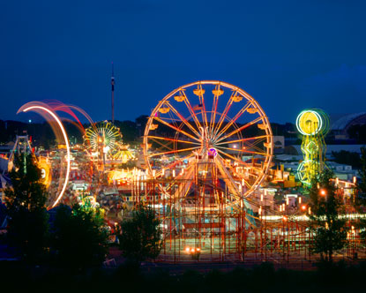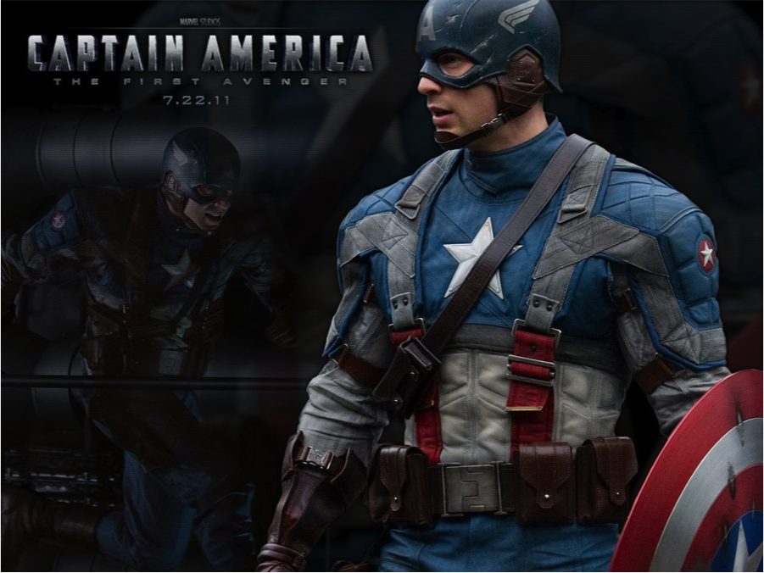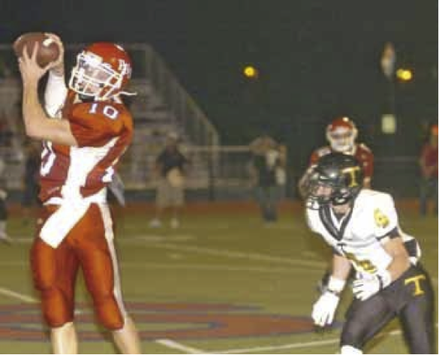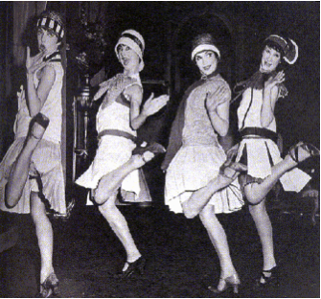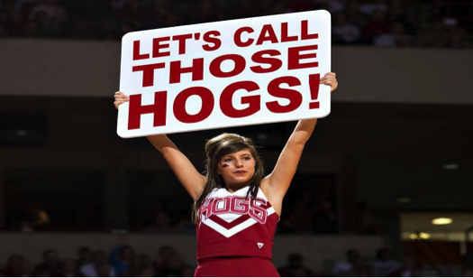

**Prohibition**

**By: Jarrett**

Prohibition is 18th amendment to ratify (or change) the constitution. This amendment said that the use of alcohol was against the law. Thinking that this will make things better is what brought this amendment, however this made things worse bringing about gangs. People that would normally never do anything wrong started smuggling alcohol, but worst of all this made Al Capone show up and slowly take over businesses and getting paid for “protection”. Finally after 13 years the 21st amendment said to forget about the 18th amendment. Because congress finally realized what was happening to everything and every one.

**Captain America- The First Avenger**

**Is he the best superhero?**

**- McKenzie**

**Captain America was originally from the 1940’s. He was a simple young man but was advanced with an experimental serum in order to aid the United States war effort. He is tough and wears a patriotic suit and carries an indestructible shield. He train to be a prop for fighting and does plays and songs, but when it comes time he takes a charge he does it right and fights for his country. Also if you are seeking edge of your seat action watch the move. In my point of view Captain America IS the best superhero!!!**

**Trumann Jr. Vs. Westside Jr.**

**By: Fowler & Garrett**

**Thursday September 20, 2012, Trumann Jr. High football team traveled to Westside for a rivalry game. Trumann opened up the game with a drive of six plays for 47 yards, then turned the ball over on an interception.**

**Westside scored off of a deep pass of 34 yards, but the 2-pt conversion was failed which left the game 6-0 Westside over Trumann. It didn’t get much better for the Wildcats after that. When Westside had a 20-0 lead going into the half. Starting the second half, Trumann kicked an onside kick and recovered the ball. With the game winding down it was all but over. Trumann had 5 seconds left to get on the board so they wouldn’t get shutout. Garrett W. connected with Trey M. on a 65 yard touchdown pass as the buzzer buzzed. Trey M. ran the ball in for the 2-pt conversion, which ended the game Westside on top 36-8. Trumann quarterback Garrett W. had 135 yards passing, 35 yards rushing and 4 interceptions, for a total of 170 all-purpose yards, while Trey M. had a total of 175 all-purpose yards.**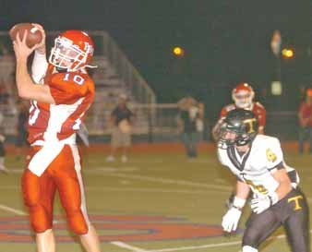

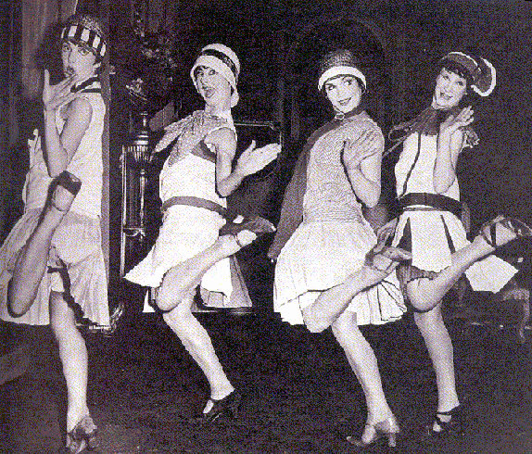 Results

If mostly a’s

A Glamorous Flapper!!!!!

If mostly b’s

A Vicious Mobster!!!

If Mostly c’s

A Talented Jazz Artist!!!!!!

Who Are You From The

Roaring Twenties?

1.What Would You Like To Do For Free time In The Twenties

a. Sing and dance on stage

b. Hold up a Saloon

c. Play instruments on stage

2. What Would Be On Your Usual Outfit In The Twenties?

a. Sequins, sequins, sequins of course!

b. Something nice and expensive to show my wealth

c. Something nice to match the rest of my band

3.Where would be your normal setting?

a. In a glamorous dressing room

b. On he streets with my “boys”

c. On stage with lots of music and fun

4. What is your favorite color?

a. Pink, silver , gold

b. Lots of black

c. Something mostly

b. Lots of black

c. Something mostly

b. Lots of black

c. Something mostly

 Results

If mostly a’s

A Glamorous Flapper!!!!!

If mostly b’s

A Vicious Mobster!!!

If Mostly c’s

A Talented Jazz Artist!!!!!!

 Results

If mostly a’s

A Glamorous Flapper!!!!!

If mostly b’s

A Vicious Mobster!!!

If Mostly c’s

A Talented Jazz Artist!!!!!!

Hogs Season 2012 by Sydney and Elle

The hogs have been kind of down lately as all of you hogs fan will know. We interviewed some teachers to get their input on the 2012 Hogs Football Season so far.

Nurse Ami: “The hogs were pitiful. She is now starting to be more of a Red Wolves fan.”

Mrs. Craft: “I am still going to support the hogs, therefore I am a proud Alumni.”

Mrs. Benson: “ They are acting lousy and bad.”

Mrs. Johnson: “ Do you really want to go there? I just hope that next year they can get someone to take them to the top. I am looking forward to basketball season.”

Coach Brown: “They are very under achieving this year, so far.”

The hogs as everyone has said are “wrecking their reputation”. Me, Elle Eaves as a proud hogs fan myself I say that they need to step up their game. Sydney Greenwell, a proud hogs fan herself also says I will support the hogs as long as they play football. Goodnight and GO HOGS! WOOOOOOOOOOOOOOOOOOOOOOO…. PIG SOOIE!!!

MacBook Airs

Our school is awesome for giving us Mac Books and I think we deserve them. They are the best computers out there. We got AYP for 4 years. I also think though that we should get to get on online games if we are completely done with our work. We need more online freedom. The MacBook Airs are still great though.

By Hunter M.





By: Hunter Montgomery

NEA District Fair

The NEA District fair is in town this week! It opened at the new fair grounds in Jonesboro on last Thursday, September 13, 2012. It closes tomorrow night at midnight. The fair is a fun way for people of all ages to enjoy themselves. They have fun rides, rodeos, competitions, beauty pageants, good food, concerts, and much more! The fair is fun, and it makes everyone happy when it comes to town.

-Katelyn & Katelyn

September 21, 2012

The Fair is in Town!