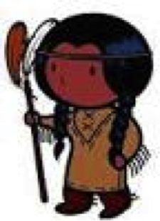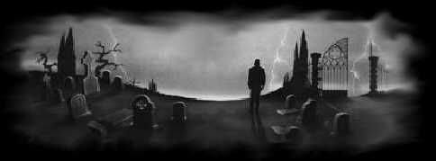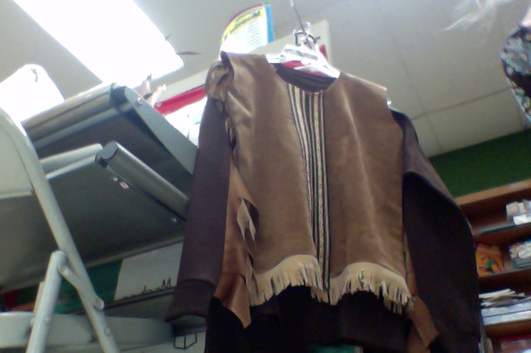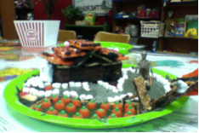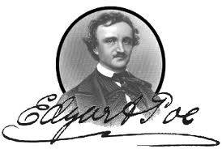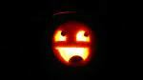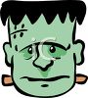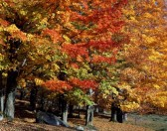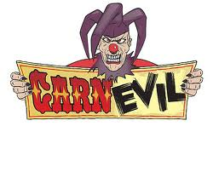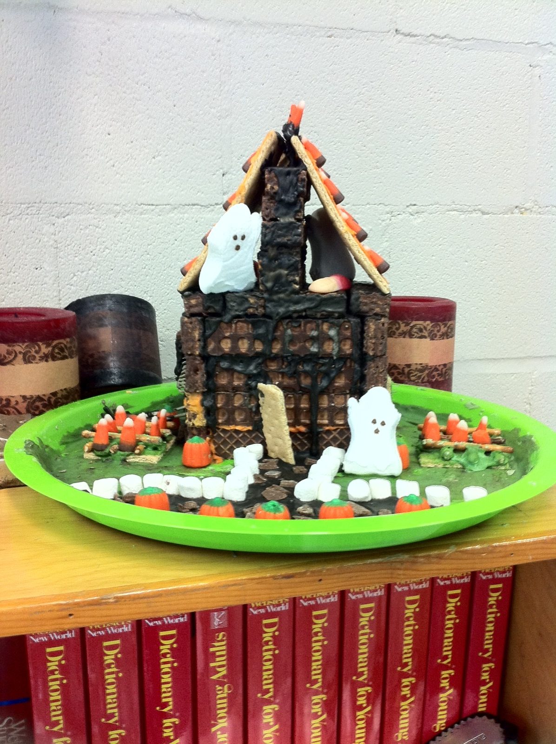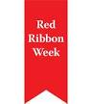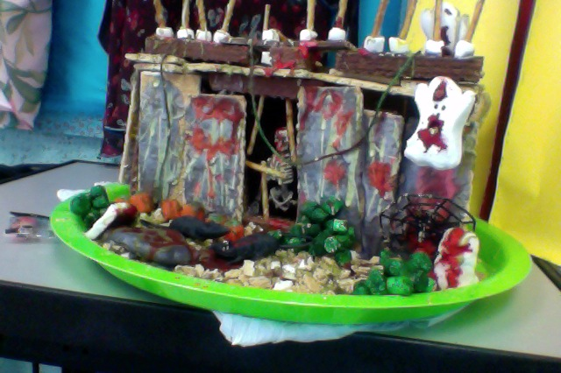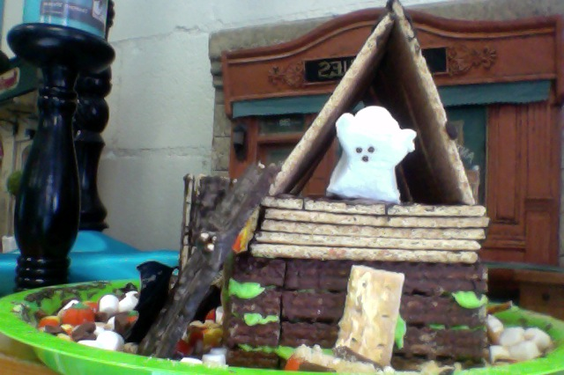

THE INDIAN CULTURE

Native Americans/Trail of Tears

The Native American’s where under siege by the white American’s. The white American’s took back their word because they found gold and silver. They tricked them to signing a peace treating and they took their land because of the gold and silver. They learned they could not trick them any more because they learned their language.

Origin of Halloween

By Amare and Terri

In G.T. we learned about the origin of Halloween.

It is fun. Halloween was originally invented in Ireland,

by the Celtics, people who lived in Ireland over two thousand years ago.

Up dates and plans for our Early American Costume Party

We are going to have a party! Do you have a costume? You can dress up like a Native American, use lots of fringe! Dress like an Early American settler, or a pioneer! You are allowed to buy your costume, but making it can be lots of fun too!

Article by Maci and Katie

Fall Festival

Will be on Oct. 29th, which is on a Monday

GT students will have a bake sale and sell

hot coco and mocha Frappuccino’s.

The Haunted Gingerbread style house construction

4TH grade haunted house

The fourth grade GT built a haunted house out of candy like a gingerbread house. It was tempting to eat but we couldn’t. We are saving it for the fall festival. We want somebody else to enjoy our fantastic work! And that person is the winner of the pumpkin-carving contest!!!!! Here is a picture of the forth grade

November GT Newsletter

Constructed by 3rd -8th grade

2012

**If you would like a good scare checkout the Raven**

**By Edgar Allen Poe! He is a master of Gothic Tales!**

Our study of Frankenstein

By Garner and London

Frankenstein didn`t really have a name. The only reason why he is called Frankenstein is because the person who made him had that name. Which was Dr. Frankenstein. The only reason he got mean is because people wouldn`t be nice to him.

Halloween written by Damon and Nick

If you want a scare, you better go to Savanna. That town is known for being haunted. They even have night tours for ghost in the city every night. They are even rumors about it being the most haunted city in America. But it doesn’t take being haunted to get into Halloween, even though most people spend Halloween in Savanna. Halloween is mainly, to us, about trick or treating and scaring people out of their socks. It is also about ghouls, goblins, and ghost. A tradition is to carve out pumpkins into jack-o-lanterns.

Halloween originated from Ireland. It started when crops began to die in fall. The Celts believed that ghost came and destroyed their crops. So, they left out “snacks” for the ghost so they would be pleased. The next day they would have a celebration with masks and costumes around the fire.

Frankenstein by Mary Shelly Sam and Amare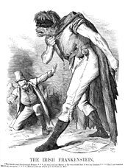

Frankenstein is a science fiction or sci-fi book by Mary Shelly.

The book is a series of letters to a man’s sister which includes a man named Victor Frankenstein who has spent his live a scientist but is ruined when he makes a monster out of dead body parts. When people mistreat him he turns evil and murders Victor’s brother, wife, and best friend. When Victor finds out, he swears to track the monster and kill it.

The G.T. Haunted House Project

Written by: Jana Kai, and Adrianna, Daly

This Halloween Season, all of the G.T. classes made edible Haunted Houses to give away as a prize at the upcoming Fall Festival. Mrs. Stevens brought all kinds of edible materials, and let the students use their creativity to create a haunted house anyway they wanted to. It was pretty challenging because you had to build it in a way that it would be sturdy enough to stand on its own, and you still have to make. In our grade we let the boys built the thing and the girls decorated it. Our class had a lot of fun building our haunted house and we hope whoever wins it!

This

The Trumann Wildcats basketball season is about to go under way. We expect for them to have a good season. Their first game will be on November 19 in Weiner, Arkansas. They have already started practicing under their head coach Skip Dulaney.

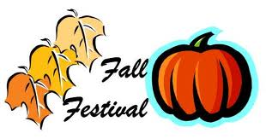 Fall festival

Written by: Jada, Maddie, and Olivia …

Monday October 28th 2012 we will be having a Fall festival at Cedar park in the cafeteria. The gifted and talented booth will serve cupcakes, cookies, and witch finger, hot chocolate, and freeze wheezy cappuccinos. Some of us will be dressed in our Halloween costumes. There will be a haunted house, jack-o-lantern contest, games, and more. We hope to see you there!!!

The Haunted Sector

Written by Zachary and Taylor

The haunted sector, or Carn-evil, has a great theme this year. Scary clowns! It’s full of scary fun and creepy clowns. If you don’t have a fear of clowns and you went through this haunted house, you will have a huge fear of clowns. It will be at the sports complex in Trumann Arkansas, from October 13th, through the 31st. If you like haunted houses you’ll go to this one. Don’t miss it.

Basketball Season is almost

Here!!!!

Article by: Jesse and Cole

Some times we question why

Little children run and scream

It may be imagination,

But are things always what they seem?

Something is chasing them

Out to eat their souls

Out to rip them all apart

Until their bodies grow cold

Don’t trust the dark

When kids all run away

They might not be crazy

So be very, very afraid

-Katelyn Stanton

~ EDGAR ALLEN POE~

~BY SAVANNAH SPADES~

Edgar Allen Poe born **Edgar Poe**; January 19, 1809 – October 7, 1849) was an American author, poet, editor and literary critic, considered part of the American Romantic Movement. Best known for his tales of mystery and the macabre, Poe was one of the earliest American practitioners of the short story and is considered the inventor of the detective fiction genre. He is further credited with contributing to the emerging genre of science fiction. He was the first well-known American writer to try to earn a living through writing alone, resulting in a financially difficult life and career.[[2]](http://en.wikipedia.org/wiki/Edgar_Allan_Poe#cite_note-Meyers138-1)

He was born as Edgar Poe in Boston Massachusetts; he was an orphaned young

when his mother died

The Mystery Writer of America presents an annual award known as the Edgar Award for distinguished work in the mystery genre.

Facts via http://en.wikipedia.org/wiki/Edgar_Allan_Poe

Red Ribbon Week BY: Jackson, Drake, and Logan

During the week of October 22, 2012 – 24 was resisting drugs week at Trumann Schools everyone got a red ribbon to wear and every day the principal would draw four people’s names to go get a prize in the office! Monday- Wear your red ribbon day! Tuesday- Red socks day! 

Wednesday- Wear all red! Thursday- Black and gold day! 

No school Friday (Hooray)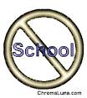

These haunted houses are prizes

For the decorated pumpkin contest!

They will be awarded to the winners

At the Fall Festival on Monday night,

October 29th!

**Haunted Gingerbread**

**written by; Madison and Kiley**

**In the past week the G.T. classes created gingerbread houses aka haunted houses, which will be in the fall festival and will be given away as a prize for the pumpkin contest. They are made out of marshmallows, nutty butters, and gram crackers so if you win one of them be where of the ghosts!**

G.T. newsletter

Trey Goff Thursday 10/25/12

Brest cancer awareness month

October is national breast cancer awareness month (NBCAM). It an annual international health campaign for the woman who has or had breast cancer and to raise to find a cure for breast cancer. NBCAM was founded in 1985 as a partnership between the [American Cancer Society](http://en.wikipedia.org/wiki/American_Cancer_Society) and Imperial Chemical Industries. October became NBCAM when NBCA was founded in 1985 during the month of October. The founder, Susan G. Komen, also had breast cancer at the age of 24.



Paige, Rives, and Riley

Fall Festival- G.T. Booth

The Fall Festival is coming up. It is on October 29th, from 6-8 PM. G.T. will have a booth in it. We will sell baked goods, hot coco, and frozen Frappuccino’s. 8th grade students will be running the booth. We will be working in 30 minute shifts.



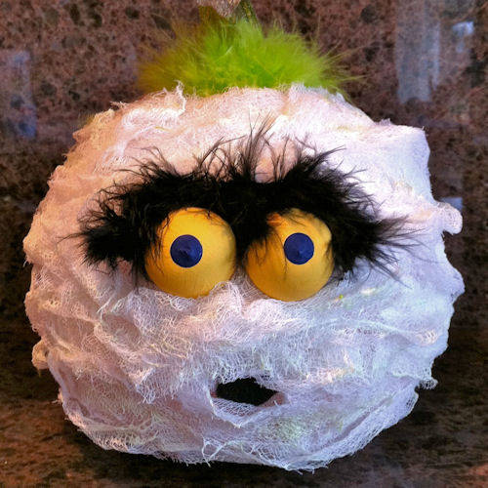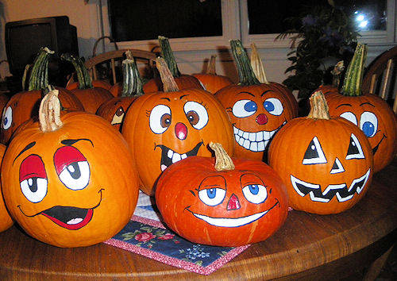

Decorative Pumpkin

Contest

$ 0.50 to enter

Bring an already decorated pumpkin to

The competition. There are six categories

So you have a good chance to win. The prizes

are the haunted houses you see displayed here.

Everyone who attends

the Fall Festival gets to

vote for

each category!!

You take your pumpkin back home with you!

[Recipient]