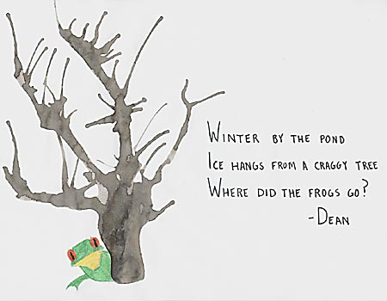 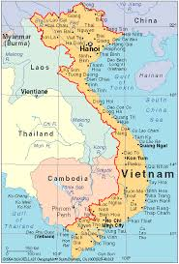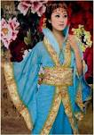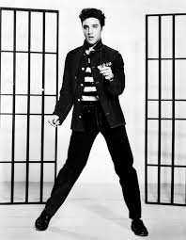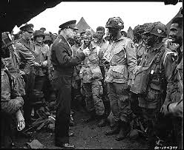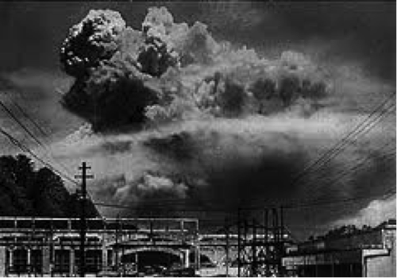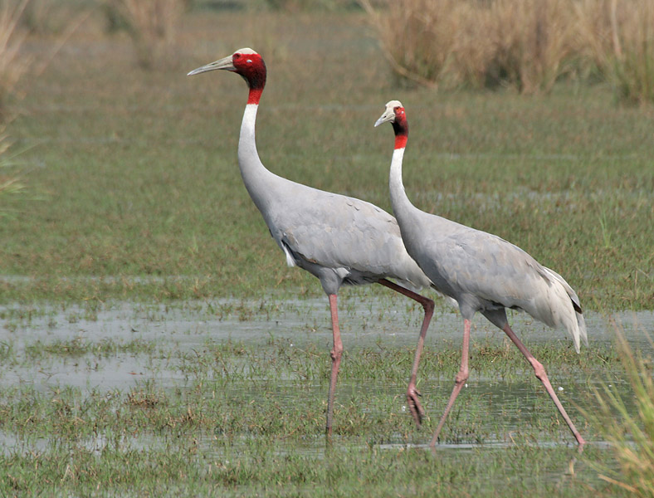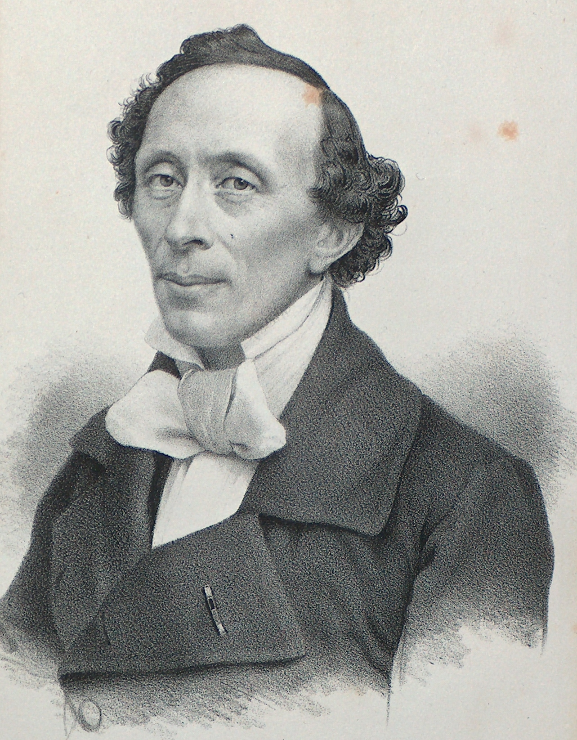

*HAIKU POEMS-*

**HI, MY NAME IS KAYTLYN AND I’M WRITING ABOUT HAIKU POEMS. I’VE LEARNED ABOUT HAIKU POEMS IN GT. HAIKU POEMS ARE VERY SPECTACULAR!**

**HAIKU POEMS COME TO US FROM JAPAN.THEY HAVE MANY SPECIAL AND CREATIVE POEMS BY CHILDREN OR ADULTS. HAICU POEMS INVOLVE KNOWLEDGE AND FEELINGS FROM SOMEONE. G.T HAS ALSO TAUGHT ME MANY DIFFERENT KINDS OF POEMS BUT MY FAVORITE IS HAIKO. EACH HAIKU POEM WORKS BY COUNTING BY USING LINES WITH 5 SYLLOBLES THEN 7 AND THEN 5 SYLLOBLES ONCE AGAIN.**

**-KAYTLYN**

Fall Festival by Anna

The fall festival was a couple weeks ago. But I didn’t get to go. But I bet it was really fun! My friend told me what there was though there was an haunted school bus and they had a cake walk and in the gym they did the Halloween obstacle course and they played games in there as well! But they also had a very exciting thing, they said that they liked it the most it was the hayride that they had there. There was a GT booth that they had lots of candy and ice cold drink that was really good. I wish that I would have been at the fall festival, from what I’ve heard it sounds like it would have been a really good time.



Football!!!! By Trenton

We did really awesome in football this year! I was a cornerback and a running back I think I did well at my job. I was on Black offense and Black defense. It was really fun for my first sport. I was a little nervous at first but when I got out on the field I was ready to run and tackle. In practice sometimes I would get hurt in pit or running the ball. In one of the games when we versed Rector, one of their kids’ facemask hit me right in the middle of the back. When the game was over we went to conference games and we won both of them. We got recognized at the high school game and everyone clapped and cheered for us! When we were at the playoffs we won the first game and we had to win one more game to get to the super bowl. That was on Saturday; sadly the other team beat us. Then on Monday we turned in our stuff. That was the end of football that year. 

### **4th grade Authors**

### the

Fall 2013

GT News

Pandas By London

Pandas are an awesome type of animal! They have been a treasure to China for a very long time. They are very picky because they only want to eat bamboo. This animal is endangered. There are very few of them left on the planet Earth. But, at Chinas Panda Reserve, Chinese scientists have found ways to breed and protect the giant pandas. I chose to write about pandas because I love their chubbiness and I want to help them. They are so adorable! I would like to thank Mrs. Stevens for letting me have this in our G.T newsletter.

THE WORLD OF ASIA

BY:ISABELLA☺

FOUR MOST IMPORTANT ANIMALS FROM ASIA ARE THE DRAGON UNICORN TORTOISE AND EPHOENIX.

IN 1972 THE PEOPLE’S REPUBLIC OF CHINA GAVE THE UNITED STATES TWO GIANT PANDAS, THERE NAMES ARE LING-LING AND HSING-HSING AND THEY LIVE IN THE NATIONAL ZOO IN WASHINGTON, D.C. IN 1984 SCHOOLCHILDREN FROM THE UNITED STATES DONATED MONEY TO HELP SAVE THE REMAINING PANDAS.

My Basketball Season

By Maddox

Basketball is a cool sport to play. However not every person will make the team, but if you do not make it you can still play against the 6th 5th and 4th grade. I like basketball because when I was little I had a little basketball goal. Now the person that made me want to play basketball was Michael Jordan. He inspired me to do my best at basketball. Now I can make a basket at the free throw line and I practice really hard. I will find out on Wednesday if I made the team but if I don’t make the team, there’s always next year.

VIETNAM QUESTIONS

By Garner

We are studying Asia my favorite part of Asia will be when we study Vietnam. There some questions that I want to know about Vietnam and here they are.

1.Does Vietnam have squirrel?

2.What all animals does Vietnam have in it?

3.What all animals went away and flew away in Vietnam?

The reason I want to know these questions about Vietnam is because my grandpa was in the Vietnam War.

4.Why did the Vietnam War start?

5.Could they use nuclear bombs in the Vietnam War?

6.How much land was destroyed in the war?

These are the questions I want to know about Vietnam.

CHINA IN ASIA

Made by: Raven

**China is very interesting if you think about it China is cool I mean look China wears cool cloths. They wear robes, cool hats, and even pins in their hair. You know what else China has an over population of RICE. Rice is good and all, but would you want to eat rice over and over again? No you wouldn’t. Another thing China is big! It has a huge wall called THE GREAT WALL OF CHINA, and they built the wall so intruders could not get in because they usually bring horses so horses cant not get over that wall so no one could really invade China anymore. So that’s cool. China is really awesome and you should check it out go-ahead read and write about China and be amazed. This is what I chose to write about in G.T. today I would like to thank Mrs. Stevens for letting me write this in our newsletter. THANK YOU MRS.STEVENS!**

**The above shows a picture of traditional Chinese clothing,**

**It’s known a kimono also known as a robe.**

###### 4th grade continued

***Elvis Presley***

***-Jose***

Last year, Elvis Presley was second in the Forbes list of top-earning dead musicians behind Michael Jackson. His estimated earnings for 2012 were $55million. The name Elvis comes from an Old Norse word meaning Squall wise'. Although Elvis's middle name on his birth certificate was 'Aaron', his grave has it as 'Aaron', which was his own preferred spelling. Elvis had a pet chimp called Scatter, which developed a taste for Scotch and bourbon. St Elvis is a small parish in Pembroke shire named after the Irish bishop St Alibi, also known as Elvis of Musters, who died in 528. The minor planet 17059 Elvis was discovered by Australian astronomer John Broughton in 1999 and named after Elvis Presley. Elvis's only TV commercial was for Southern Made Doughnuts in 1954. His only line of dialogue was: You get 'me piping hot after 4am. At the age of 36, Elvis Presley became the youngest recipient of a Grammy Lifetime Achievement Award. The alphabet positions of the letters in 'Presley’' add up to 100.

Manhattan Solution

BY: A.J.

In 1945, Americans decided to end World War 2 quickly and painlessly. In doing so, they devised the Manhattan Project. It was named this to conceal the fact that they were trying to build a nuclear bomb without anyone’s notice. They had remarkable scientists assisting them in the construction of the bomb. It was designed to kill thousands of people at once. Soon, Harry Truman became the President of the United States once Roosevelt passed away shortly after he was elected for his 4th consecutive term. After much difficult work and research, the bombs were finally prepared for their purpose. On August 14, 1945, Harry Truman gave the order to drop the bombs on Hiroshima. Thousands upon thousands of innocent people were murdered, yet they figured it was necessary, because the Japanese were so desperate, they began arming citizens and bringing them into war. When they began such drastic action, the Americans figured if they began bombing Japanese places, it would strike a fatal blow to their side. When the bombs were dropped, immediately the radiation poison overcame large amounts of people. Buildings instantly burst into flame; many of the people were helpless at the time.

Even though there was great tragedy in Hiroshima, for the Americans the fun wasn’t over yet. They knew they only got half their job done. Shortly after the Hiroshima bombing, they also attacked Nagasaki. That bombing might have even been worst than the first. When it was over, at least a quarter million people were killed. The day after this happened, the Japanese immediately surrendered out of fear. Over the years, the toxic residue still remained, killing the survivors. This affected animals also. It was a victory yet a horrible tragedy t that will live in our hearts forever.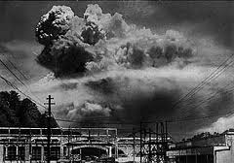

***The Axis Powers and the Allied Powers*** by Savannah

World War 2 was fought between two groups of nations. One of the groups was called the Axis Powers, and the other was called the Allied Powers. The Axis Powers involved Italy, Germany, and Japan. Some of the countries in the Axis Powers didn’t even fight in the war such as, Hungary, Bulgaria, Romania, and Finland. The Allied Powers involved, Great Britain, Britain, France, Russia, and United States. Some of the countries were only in the Allied Powers because the Axis Powers had attacked them, such as Poland and China.

The leaders of the nations were, Benito Mussolini, Victor Emmanuel the 3rd, and Ugo Cavallero, (Italy), Adolf Hitler, Heinrich Himmler, Hermann Göring, and Erwin Rommel, (Germany), Hideki Tojo, Isoroku Yamamoto, Osami Nagano, and Emperor Hirohito (Japan). The leaders of the Allied Powers were, Winston Churchill (Great Britain) Harry S. Truman, George Marshall, Dwight D. Eisenhower, Douglas MacArthur, and George S. Patton, Jr. (United States), Georgy Zhukov, Vasily Chuikov, and Joseph Stalin (Russia), Bernard Montgomery and Neville Chamberlain (Britain), Chiang Kai-shek and Mao Zedong (China), and Charles de Gaulle (France).

The Axis Powers was formed on October 15th, 1936. Germany and Italy signed a friendship treaty signed a friendship treaty that formed the Rome-Germany Axis. Shortly after on November 25th, 1936, Japan and Germany both signed the Anti-Comintern Pact.

The Allied Powers was formed on October 12th, 1940 in Versailles, France to have power like the Axis Powers did. Overall the Allies won because they where stronger, and better than the Axis powers.

# D-DAY

*The Invasion Of Normandy*

*The invasion of Normandy took place June 6th, 1944. June 6, 1944, 160,000 Allied troops landed along a 50-mile stretch of heavily fortified French coastline to fight Nazi Germany on the beaches of Normandy, France. General Dwight D. Eisenhower called the operation a crusade in which “we will accept nothing less than full victory.” More than 5,000 Ships and 13,000 aircraft supported the D-Day invasion, and by day’s end on June 6, the Allies gained a foot- hold in Normandy. The D-Day cost was high -more than 9,000 Allied Soldiers were killed or wounded but more than 100,000 Soldiers began the march across Europe to defeat Hitler.*

Basketball

By: Jonah

I have a good feeling about basketball this year. This football season was great but, I think basketball will be better. Our first game is next Monday the 11th. In my opinion basketball is one of the hardest but most fun sport.

Basketball is really fun. Any athletic person would really like it.

LEARNING ABOUT THE 40’S AND 50’S

# 6th Grade GT

More 6th Grade Articles

What Learning Leaf Best Describes You

By: Lauren



Are you a crisp red visual leaf or does a forest green pokey leaf best describe you? There are many different learning styles, but the three main styles are auditory, visual, and kinesthetic. Everyone has their own process in which they like to study or learn.

An auditory person likes to hear things and they would rather listen to the reading than have themselves read it. They like explanation instead of figuring it out. When studying these different people like to have background music and they like reciting their work out loud. This style of learning is like the crisp red leaves because they are easy going, bright, but still like guidance.

A visual human loves looking at charts and graphs. That’s where they best succeed. Unlike an auditory person they can’t stand an explanation they like helping themselves. They are like the bright green leaves; they like being different and doing things on their own.

A kinesthetic being is best at hands on project; they can study better doing activities than any other study method. These people tend to lack a long attention span during a long lesson. They are the bright yellow leaves they can’t grasp on the tree for a long time.

What color leaf best describes you? I’m a very visual person; I can’t stand help and I love figuring out charts and graphs. While reading did you figure what color best fits you?

Thanks for Reading!!

V-J Day

Hi my name is Chloe and I am talking about the cranes.

Their where once cranes in Vietnam.

And they left after the war because, the Vietnam people drained there water and Went to war. I think they would have stayed if they wouldn’t have went to war I loved the part where the cranes came back. they where happy when they did come back I loved it how there was some conflict By: Chloe

Hi I am Ethan and I’m going to tell you about Japan and it’s technology

Japan has a lot of smart people. They are good with technology. They even have holograms!!! If you like video games they made allot of them including Pokémon, Kirby, Mario and sonic! They also have hats that reach your brain waves and read your emotions and the ears of the hat go up when your sad the ears of the hat go down.

Mr. Hans Christian Anderson,

Prince of Fairy Tales

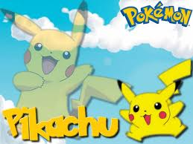

# The Cranes

**More 4th Grade GT** articles

**Hans Christian Anderson**

**By: Drew**

Hi my name is Drew and I am going to tell you about Hans Christian Anderson. I also want you to know that I like learning about him.

He lived over 200 years and he wrote over 150 books! His parents died when he was a preteen. A wealthy businessman and his family took him in as an adopted son. He went to school because the King of Denmark and the businessman paid for his education. That is where he learned to read and write. If it wasn’t for school he would not have became a famous writer!

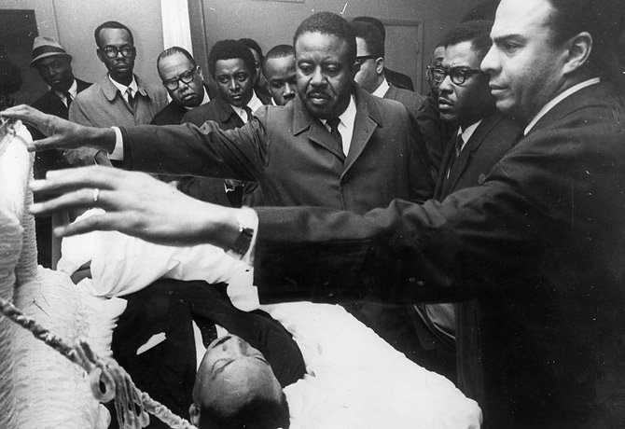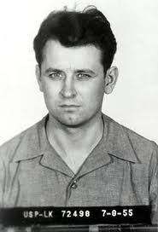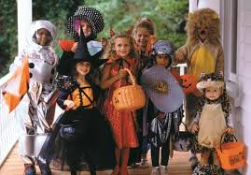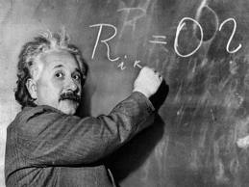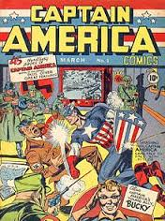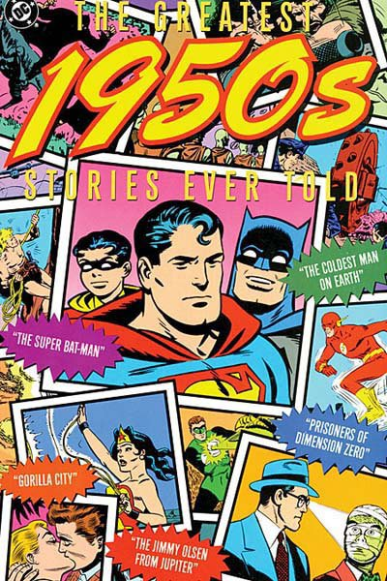[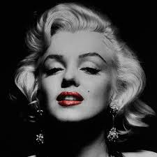](http://www.google.com/imgres?client=firefox-a&sa=X&rls=org.mozilla:en-US:official&channel=fflb&biw=821&bih=589&tbm=isch&tbnid=7BGn0ptAnRhMmM:&imgrefurl=http://fineartamerica.com/art/all/marilyn+monroe/all&docid=P6Zw-jYAFnhuJM&imgurl=http://images.fineartamerica.com/images-medium-large-5/marilyn-monroe-3-andrew-fare.jpg&w=900&h=900&ei=2qN6Ur3tMIe7kQfMw4DgCw&zoom=1&ved=1t:3588,r:19,s:0,i:146&iact=rc&page=2&tbnh=176&tbnw=162&start=9&ndsp=14&tx=95&ty=101)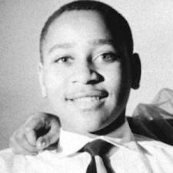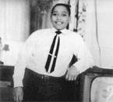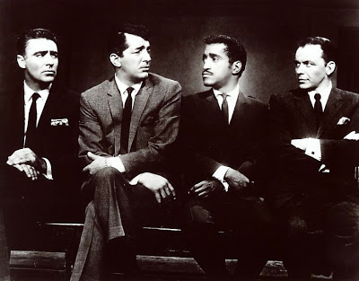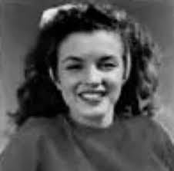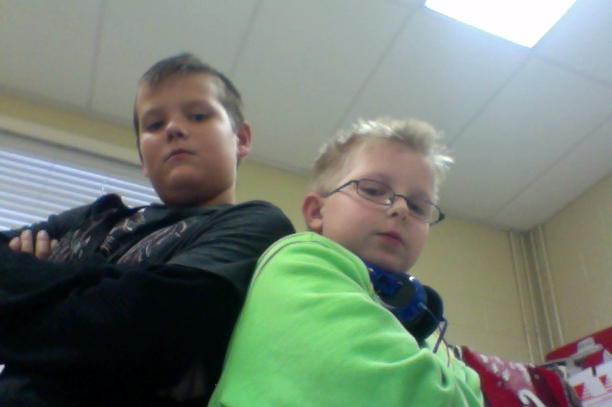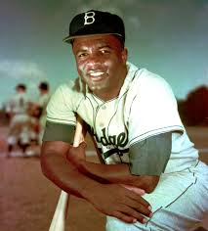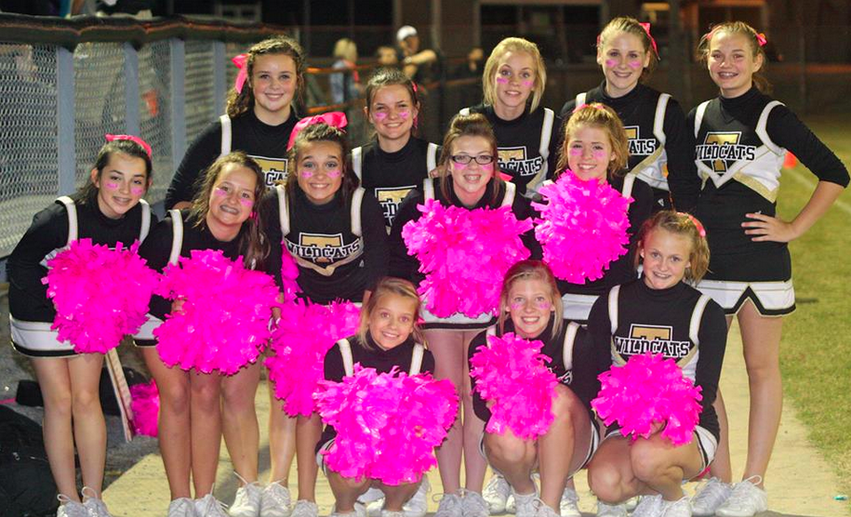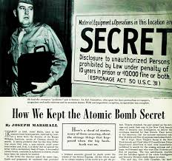

http://sfcherryblossom.org/

The Cherry Blossom festival occurs in the season of spring. It is the designated time to honor Japanese-American culture in San Francisco. Japanese-American families plan for weeks, creating skits, art, music, dance, parades, games and foods to honor their culture in a festival style atmosphere. It is a celebration of nature, culture and heritage.

The Cherry Blossom Festival

We are learning about Asia and how it is the most populated continent of all seven continents in the world. We also learned that Giant Pandas come from the country of China, which is part of Asia. Giant Pandas eat bamboo and live in a bamboo forest. They look very cute but are actually very fearce. We talked about the fact that China allows some countries to host Pandas at a few Zoos’. One such zoo is the Memphis Zoo. We looked it up on the Internet and viewed live footage of a Giant Panda eating bamboo from a panda cam. If you would like to see the pandas in real time, the address is provided below.

Is listed below.

http://memphiszoo.org/pandacam

3rd Grade GT Authors

Giant Pandas

Fall 2016

Not JUST A WALL!!!!! 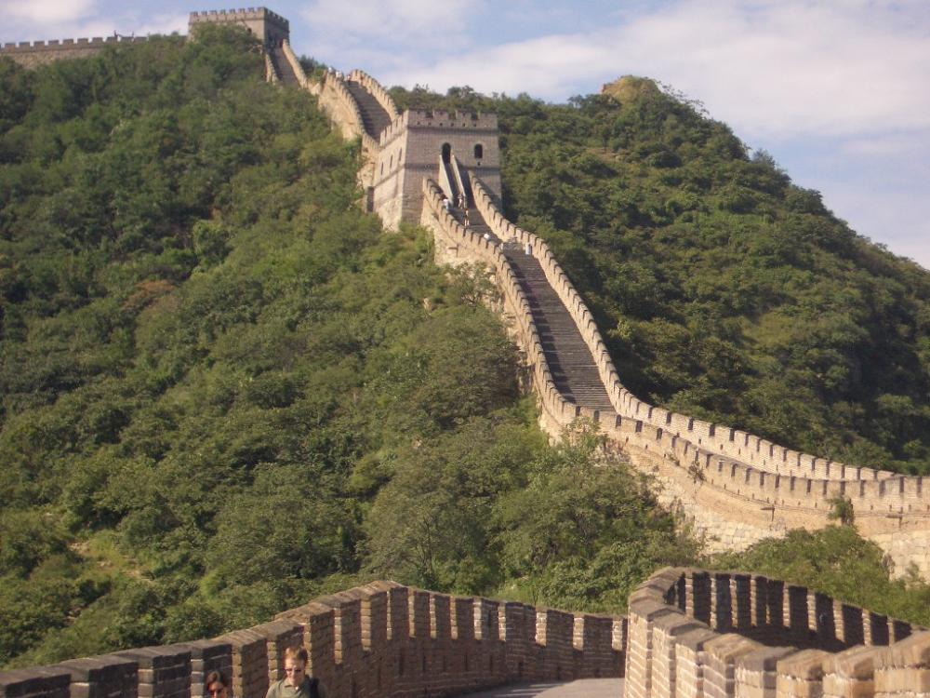

BY: Zoey

The Great wall isn’t just a wall! It has a very interesting meaning! The Great wall was built over 2000 years ago around 221 BC. It was built to keep invaders from Mongolia out. It is 21,196 km long!!!!!!! It was also built high up because the invaders from Mongolia traveled by horse and they couldn’t get the horses up the wall. The Great Wall was also built to keep goods from being smuggled out of china. Before the use of bricks the great wall was mainly built of rammed earth stones & wood however, during the Ming Dynasty bricks were heavily used in many areas of the wall, as were materials such as TILE, LIME &stone. Now, whenever you think of the great wall remember it’s not just a wall!

Malaysia

Hi my name is Michael and I’m most interested in Malaysia here is some facts about Malaysia.

*Malaysia is in South-east Asia.

*Out of 100 Malaysians, 47 are Malay,33 are Chinese and 9 are Indians.

*The railway station in Kuala Lumpur was built in 1963.

*Malaysia lies just north of the equator and has tropical climate.

*In 1981,Malaysia produced nearly half of the world’s rubber.

*About half the people of Malaysia work on farms.

*Palm oil is Malaysia’s second most valuable farm export.

4th Grade GT Articles

This man is the one who shot Dr. King.

**Dr. Martin Luther King Jr.**

Created By: Caroline and Caera

Have you ever heard about Martin Luther King Junior? Now is your time to!

Martin Luther King Jr. was born on January 15, 1929, Atlanta, Georgia. Growing up as a child for him was not easy because of segregation. He was the second of three children and at first he was named Michael after his father but they both changed their names to Martin when he was still young.

He had a beautiful wife named Coretta Scott King and 4 beautiful children. When he got older he wrote the I Have a Dream speech on August 28, 1963, 5 years before he died. James Earl Ray shot Martin Luther King Junior on April 4, 1968 while staying in a hotel in Memphis, Tennessee. It brought great Greif to his family.

As you can see, Martin Luther King Jr. was a great man and he brought a lot of joy to the world!



Fall Festival 2013

By: Jenny (A 6th Grade GT Student)

Every year we have a Fall festival at Cedar Park, the G.T. program always participates in it. The G.T. program sold cookies, cakes, candies, and frappuccino’s. We had anywhere from sweet cupcakes too gobling eyeballs on a stick. I’m sure evryone got a kick out of the eyeballs. We were so busy, and people loved our stand. Most of the students donated either store bought foods or homeade foods also with the generosity of Mrs. Stevens, everything came together.

The whole place was packed, everyone had a great time. There was a cookie making stand, a haunted school bus, a hayride, a cake walk, an obstacle cousre in the gym, food stands, and best coatume and best pumpkin competitions. It was a lot of fun!

Einstein and his theory of relativity by Kelsey 11/5/13 10:35 AM

Albert Einstein was born on the 14th of March 1879 in, ULM, Germany. He had gone to school and was a bit of a troublemaker his professors were ruff on his. When he got older he had become a professor in relativity and moved to America. He had so much knowledge about relativity that he had came up with the theory of relativity which was E=MC2 which has been so helpful in so many ways but after that he won The Noble Prize in 1922.

The reason that he moved to America is cause Hitler was killing al the Jew’s that he could find. He was a Jew and he wanted to live. Even today his ligase lives on very smart people are called little Einstein’s.



Captain America

By Sam

Captain America back in the 40s’ was entertainment and was made to give hope to the people during the war. He was created by Marvel in real life, but in fictional life he was giving a serum, which gave him strength speed and stamina. Or the three Ss’. His fame has grown over the world and Marvel and has joined many teams in comics including The Avengers, The Secret Avengers, The White Star, and S.H.I.E.L.D. In real life, he has been inspiration for justice and freedom, and helping you’re friends. In the comic book series Civil war, Cap shows freedom when refusing to register his identity and says that Americans should have freedom, not the government watching them 24/7.

1950’s Pop Culture

by: Maci and Cierra

The 1950’s was a great era in history, It had many great things such as Comic Books, T.V shows, and Music. Super Man was a popular comic book in the 50s, it talked about a normal man hiding a secret super hero identity. A popular T.V show was I love Lucy, It had a star with the name Lucy or Lucille and it was stated hillarous. Elvis Presley was a great muscian. When Adults first seen him they did not like his rock n’ roll moves and stated that it was the music of the devil. But he slowly became adored by fans. You see the 50’s was a wonderful time filled with milkshakes and poodle skirts, but next time think about stuff like Super Man, I love Lucy, and Elvis!

**Fifties Pop Culture**

5th Grade Authors

Marilyn Monroe

By Hannah and Amare

Marilyn Monroe was born on June 1, 1926 in Los Angeles. Her actual name was Norma Jeane Mortenson. She was an American model and singer. Her mother was a film cutter. Marilyn dropped out of school at age 15. Marilyn’s first movie was in 1947 and she had a bit of a part called The Shocking Miss Pilgrim. After that she went back to modeling and acting school. In 1948 Columbia Pictures then picked her up in a play to play Peggy Martin in The Ladies of the Chorus. In 1951 she got a fairly sized role in Love Nest where she played an unbalanced babysitter. She made 30 films in her lifetime. Her nicknames were The Blond Bombshell and MM. Her height was 5’5½. She had a prized autographed photo of Albert Einstein and also said on it to Marilyn, with respect and love and thanks. She died August 5, 1962 at age 36 of drug overdose.

Emmett Louis Till

By: Kaylee and Jacie

Emmett Louis Till was born in Cook County Hospital on July 25, 1941. In Chicago, Illinois. His mother and father were named Louis Till and Mamie Till. He went to Mccosh Elementary School. He lived till he was 14 years old. He died because Roy Bryant and his half brother J.W Milam murdered him. He was murdered near Money, Mississippi on August 28, 1955.

How Emmett Louis Till was murdered

When Emmett Till was 14 years old he was murdered. This is how. He was visiting his relatives in Mississippi when he was snatched from his great-uncle’s house on the night of August 28,1955. He was beaten, shot in the head, and thrown into the Tallahatchie River by Roy Bryant and his half-brother J.W Milam.

This is a picture of Emmett Louis Till

**Albert Einstein**

**By Spencer**

Albert Einstein (14 March 1879 – 18 April 1955) was a German-born [theoretical physicist](http://en.wikipedia.org/wiki/Theoretical_physics) who developed the [general theory of relativity](http://en.wikipedia.org/wiki/General_relativity), one of the two pillars of [modern physics](http://en.wikipedia.org/wiki/Modern_physics) (alongside [quantum mechanics](http://en.wikipedia.org/wiki/Quantum_mechanics)). While best known for his [mass–energy equivalence](http://en.wikipedia.org/wiki/Mass%E2%80%93energy_equivalence) formula *E* = *mc*2 (which has been dubbed "the world's most famous equation"),he received the [1921](http://en.wikipedia.org/wiki/List_of_Nobel_laureates_in_Physics) [Nobel Prize in Physics](http://en.wikipedia.org/wiki/Nobel_Prize_in_Physics) "for his services to theoretical physics, and especially for his discovery of the law of the [photoelectric effect](http://en.wikipedia.org/wiki/Photoelectric_effect)".The latter was pivotal in establishing [quantum theory](http://en.wikipedia.org/wiki/Introduction_to_quantum_mechanics).

Near the beginning of his career, Einstein thought that [Newtonian mechanics](http://en.wikipedia.org/wiki/Newtonian_mechanics) was no longer enough to reconcile the laws of [classical mechanics](http://en.wikipedia.org/wiki/Classical_mechanics) with the laws of the [electromagnetic field](http://en.wikipedia.org/wiki/Electromagnetic_field). This led to the development of his [special theory of relativity](http://en.wikipedia.org/wiki/Special_theory_of_relativity). He realized, however, that the principle of relativity could also be extended to [gravitational fields](http://en.wikipedia.org/wiki/Gravitational_fields), and with his subsequent theory of gravitation in 1916, he published a paper on the [general theory of relativity](http://en.wikipedia.org/wiki/General_theory_of_relativity). He continued to deal with problems of [statistical mechanics](http://en.wikipedia.org/wiki/Statistical_mechanics) and [quantum theory](http://en.wikipedia.org/wiki/Quantum_mechanics), which led to his explanations of [particle theory](http://en.wikipedia.org/wiki/Particle) and the [motion of molecules](http://en.wikipedia.org/wiki/Brownian_motion). He also investigated the thermal properties of light which laid the foundation of the [photon](http://en.wikipedia.org/wiki/Photon) theory of light. In 1917, Einstein applied the general theory of relativity to model the large-scale structure of the [universe](http://en.wikipedia.org/wiki/Universe).

He was visiting the [United States](http://en.wikipedia.org/wiki/United_States) when [Adolf Hitler](http://en.wikipedia.org/wiki/Adolf_Hitler) came to power in 1933 and did not go back to Germany, where he had been a professor at the [Berlin Academy of Sciences](http://en.wikipedia.org/wiki/Prussian_Academy_of_Sciences). He settled in the U.S., becoming an [American citizen](http://en.wikipedia.org/wiki/Citizenship_in_the_United_States) in 1940. On the eve of World War II, he endorsed a [letter to President Franklin D. Roosevelt](http://en.wikipedia.org/wiki/Einstein%E2%80%93Szil%C3%A1rd_letter) alerting him to the potential developing of "extremely powerful bombs of a new type" and recommending that the U.S. begin similar research. This eventually led to what would become the [Manhattan Project](http://en.wikipedia.org/wiki/Manhattan_Project). Einstein was in support of defending the Allied forces, but largely denounced using the new discovery of [nuclear fission](http://en.wikipedia.org/wiki/Nuclear_fission) as a weapon. Later, with the British philosopher [Bertrand Russell](http://en.wikipedia.org/wiki/Bertrand_Russell), Einstein signed the [Russell–Einstein Manifesto](http://en.wikipedia.org/wiki/Russell%E2%80%93Einstein_Manifesto), which highlighted the danger of nuclear weapons. Einstein was affiliated with the [Institute for Advanced Study](http://en.wikipedia.org/wiki/Institute_for_Advanced_Study) in [Princeton, New Jersey](http://en.wikipedia.org/wiki/Princeton,_New_Jersey), until his death in 1955.

There are seven types of learning styles according to this website, which is based upon Howard Garners Theories of Intelligences.

Visual, Social, Physical, Aural, Verbal, Solitary, and Logical.

The first one is Visual (spatial) means you prefer to use images, pictures, colors, and maps to communicate with others.

The next one is social (interpersonal) you love to communicate with others well and you love to be around them.

Then Physical, (bodily kinesthetic) you use hand motion and body motion.

Aural (musical) you love music.

Then Verbal, (linguistic) you like written or spoken to learn.

Another is Solitary (intrapersonal) you’re shy, private, introspective, independent.

The final one is Logical (mathematical) you love using your brain.

Every one of these is a certain person’s way of grasping knowledge.

**Learning Styles by Teri**

**By Whitney**

Emmett Louis Till was an African American boy who was killed in Mississippi when he was only 14 years old. He was killed because of jealousy. He would always flirt with a white woman at a local grocery store, and others got jealous and hurt Emmett. Emmett was beaten; one of his eyes were gouged out, shot in the head, and was thrown into the Tallahatchie River. His body was found three days later. Emmett was a wonderful child, and I think he deserved a long life, longer than he actually lived. Rest in peace Emmett.

**Emmett Till**

**The Rat Pack**

By: Madison

The Rat Pack is a group of people that were actors as well as singers and ran around together all the time. They were consisting of Frank Sinatra, Dean Martin, Sammy Davis Jr., Peter Lawford, Joey Bishop, and for a short time, Norman Fell. All of these people went together and appeared on stage together in the early 1960’s with movies such as Ocean’s 11 and Robin and the 7 hoods.

For a short time, Marilyn Monroe, Angie Dickinson, Juliet Prowse, and Shirley MacLaine were considered the mascots of the Rat Pack. Sometimes when they would perform at the hotels, the marquees would read “DEAN MARTIN – MAYBE FRANK – MAYBE SAMMY.”

**Marilyn Monroe**

by Riley

Marilyn Monroe born as Norma Jeane Mortenson was an all around great woman. She was born on June 1, 1926 in Los Angeles, California. Marilyn is an American icon still known today. She continues to inspire many actresses and models to this day to pursue their dreams.

**The Struggle between the races**

**An overview of the Civil Rights Movement**

**by Paige**

There was much racial indifference in the United States in the 1950s. The civil rights movement was in that time period. There were many marches and boycotts, speeches and speakers. Some significant people of this movement were Dr. Martin Luther King, Jr., Rosa Parks, and Emmett Till.

MLKJ was an American clergyman, activist, humanitarian, and leader in the civil rights movement. He is known for his role that he played in the movement without using violence. He is a national icon.

Parks was an African-American activist. She is known as the “first lady of civil rights” and “the mother of the freedom movement.” Her birthday and the day she was arrested are recognized in California and Ohio as “Rosa Parks Day.”

Emmett Till was a fourteen-year-old boy that was murdered for flirting with a white woman. The woman’s husband murdered Till very gruesomely and dumped him in a river. Till’s mother published the photo of the recovered corpse to show the world what the men had done to him, supposedly because he was black.

8th Grade GT

Your Wildcat News!

By P.J. and Jordan

Well this year the 5th and 4th football team was 7/0 this year with outstanding plays causing them to get into the playoffs! There was one team that beat the wildcats and that team was Newport.

This year the wildcats were conference champs in the first time in 4 years. Now you know the daily wildcat news with P.J. and Jordan.

Learning about Jackie Robinson

By Journey and Caidyn

On January 31, 1919, Jackie Robinson was born. He was a famous baseball player and he also did track. He grew up in Cairo, Georgia. Jackie Robinson and his family moved to Pasadena, California in 1920 when his dad left them. He had a family of sharecroppers. Also, Jackie Robinson’s real name is Jack Roosevelt Robinson.

In 1936 when Jackie was seventeen he went to George Washington High in Pasadena. In 1941 Rachel Isum met Jackie at UCLA (track meet). 1942 Jackie joined the army and Rachel learns about nursing in San Francisco. 1946 Jackie and Rachel get married in February. November 18, 1946 they have their first child Jackie Jr.

In 1946 April 15 Jackie breaks the color line. In 1949 Jackie becomes National Leagues Most Valuable Player. At the age of 53 Jackie Robinson died October 24, 1972. His number 42 was retired, that is other players are unable to ever use it. This was done to show their great respect for Jackie Robinson.

Junior High Cheer

My name is Maddie. I’m a junior high cheerleader. I’m telling you about what the cheerleaders did for the month of October. It was the month to support breast cancer, and of course, wear PINK!!! Which happens to be one of my most favorite colors!

We all wore pink bows, and had pink pompoms. It was a really fun month and it felt good to know that I was supporting everyone who has or has had breast cancer. Also, we wore pink football stripes under our eyes with names of those who we love on them. I hope that because of all of our efforts, Trumann now has an increased awareness of what breast cancer is.

The Manhattan project

By: Luther and Connor (5th gr. GT)

The Manhattan project was about the atomic bombs.

When Harry s. Trumann was going to end the Japan war so he and other scientists planed to use the atomic bomb. The atomic bomb was top secret. So secret they didn’t discus the name in public. They didn’t want to let the secret out.

When they finally dropped the atomic bomb they discovered that when chemicals get out it can cause people to die ten years later. It will cause sickness and even death a lot of times. It was due to the he use of these bombs that helped us end the war with Japan.

TRUMANN LADY WILDCATS BASKETBALL

By: Adrianna

My name is Adrianna. I’m a seventh grade basketball player. This year the 7th grade basketball team will have the best year ever! I think this because we are a lot more experienced, or at least the players coming back from last year are. We have been together for 3 years. We have a new wonderful coach. We gained some more players that are caching on fast. We have Coach Haynes and Coach Brown who make us a better team. Coach Brown is head coach of the senior high team. Coach Haynes is the head coach over junior high also the 7th graders. The starting five players are Hannah, Tay’anna, Adrianna, Jana, and Madeline. Come out and support your Lady Wildcats on the date of November 14,2013. This occasion will be held at Trumann High School gym starting at 5:00 pm.

#Should’veBeenAWildcat

UNDEFEATED

By cole

The Trumann 7th grade football team completed there undefeated season with a 20-12 win over the Highland Rebels. Our Head Coach Waymire was very proud and told us he wanted us to stick together and in high school we would go far in the game. We will all be moving to the Jr. High team on Monday. Our coaches concluded by saying, “We will encourage everyone to stick together so when you get older you can be very good and go win the state finals.”

Coach White said that he was also very proud and he was going to be there every step of the way. Also TE/LB Cole said, “ I am very proud of how we stuck together and we didn’t quit all year no matter what the score.”

My First Year In The G.T. Program

My name is Payton, and this year is my first year in the G.T. program. I have had such a boisterous and prodigious year. I have learned more in the G.T. program than I have anywhere else. Our teacher Mrs. Stevens is the most helpful and gracious person I have ever met. She has taught us so much! I am very exited about learning about the decades of 50’s and 60’s. I think I will have a lot of fun and interesting experiences.

I am also exited about the fact that we get to go on a field trip to Graceland, a place in Memphis TN. It is where the very famous rock singer Elvis Presley lived. Hopefully, we will get to go on the 5th of May. It will be an amazing ending to a spectacular year!