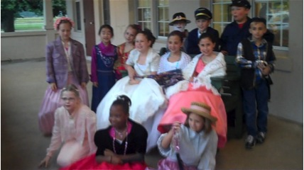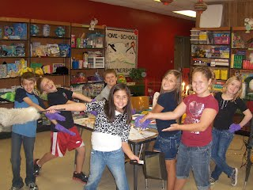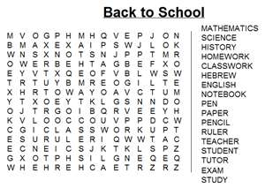

Interested in finding out more about Common Core and what it means

To Arkansas Schools? Here is where to look:

http://ideas.aetn.org/commoncore/

*"All Arkansas students deserve an education that prepares them for college and careers. Access to a college and career ready education shouldn't be determined by a student's ZIP code. That's where Common Core comes in."*

*— Arkansas Education Commissioner  Dr. Tom W. Kimbrell*

Common Core State Standards

What is their major objective?

Where can you find out more about Common Core?

Page 5

Looking back

A summary of our 2011-12 GT Program

Communication is Key!

Plans for increasing student writing & editing skills and keeping parents informed and involved

Page 4

Page 6 First week of GT

See Page 2

Welcome and let’s get acquainted

Issue 1 Month/yr.; August 2012

Gifted, Talented and Creative Newsletter

Layout of topics

Question and Answer page about our Trumann GT Program

Newsletter overview

Page 3

Page 2

Page 1

Back to school puzzle page

Find out more about the Trumann GT Program and where to get more information.

## Good news for GT Students!

+

+

Why must we sign the annual continuation of GT services form?

If your child has been identified as gifted and you want them to continue to receive GT services this school year then you the parent must sign the Trumann School District Annual Continuation of Gifted & Talented services Conference Record with Parental Consent form.

W

**Here is why . . .**

**In compliance with GT AR standard 7.02 Identification procedures are clearly stated, uniformly implemented, and communicated to all stakeholders. Compliance Indicators must include: State identification process (including how procedures are communicated). A review of students’ placement in the G.T. program is made at least annually. Before placement or continuation of service, parental consent must be granted for any student to receive services in the Gifted and Talented Program.**

### Trumann Gifted and Talented Program Questions and Answers

Question: Who can refer a student?

Answer: Parents, Teachers, or students (can refer self or a friend).

Question: What is the identification process?

Answer: The identification process is the period of time after a referral has been submitted, then a portfolio containing assessments, student work samples, and questionnaires will be assembled in order to determine whether a student is in need of GT services.

**Answers to questions such as**

* **How to make a Referral**
* **What is the identification process**
* **What are some program options?**
* **What is the annual placement consent form about?**

Below you can find answers to questions about our GT Program

“He puzzled until his puzzler was sore”

# Puzzle over Puzzles

# It’s great for the brain!

You know what? We could even dedicate a section to parent feedback! That way communication can be two-way! Wow, this is going to be fantastic!

In closing, I just wanted to say that every grade level of GT student, exceeded my expectations last year and I have no doubt that they will all surpass expectations on this GT Newsletter throughout this up coming school year.

I don’t know about you but I can’t wait to see what they will do!

You may have noticed that I mentioned differentiation. Well differentiation is all about options and choice. In other words not requiring the same thing to be done the exact same way by every student. So, my idea on how this will fit into our program, seamlessly, is to allow the students who finish assignments early—and there are always several, the option of working on the GT Newsletter. They can work on a peace independently or as a group.

I will of course approve topics and editorials before publication.

Additionally with all of this being digital, they can work on a peace until they are ready to submit it for approval and then it will be published. If too many articles/peace's are submitted that month, we will use the democratic process and vote for the favorites. Then the remaining can go into the next publication.

What is the plan?

As we know there are various forms of communication. One of which is writing, another is art. So my plan is to utilize both in order to accomplish duel goals. 1. Increase student writing skills (while making it meaningful and fun so that learning is intrinsic) and 2. Increase communication with all stakeholders, namely parents as well as teachers.

The plan is to accomplish both goals by having GT students assist me with planning, preparing, writing, editing this monthly GT newsletter.

Since it will be posted on the web on our GT web page, they will have a forum in which their voice can be heard.

They can share their poetry, opinions, and artwork if they choose. This GT Newsletter project will enhance differentiation options in the GT classroom as well as make fantastic use our new technology! Just think of it. The sky is the limit! They will have creative options from the symbolism in the pictures they choose, to the perspective and writing style they incorporate into their piece.

I don’t know about you but I’m very excited!!!!

**Communication is Key!**

+

We have had a wonderful year!! To recap here are a few highlights! We have a new GT web site with easy access to the GT handbook, referral forms, survey forms, and super pictures of our GT students and the engaging  events from this year!! At the Elementary level we had the Milky Way Galaxy Unit of Study (Research/ Power Point Presentation / Creative group collaboration)  and the Planetarium exhibit (another group collaboration in creativity and problem solving). We also researched and studied the Civil War Era and had an exciting Civil War Costume Party to commemorate the Sesquicentennial of the Civil War in Arkansas. The elementary GT students also studied many great poets and read the biography of the amazing author Mark Twain (who happened to live during the Civil War and beyond). Next, at the Intermediate level, we had the Renaissance Festival/unit of study (chocked full of research, creativity and problem solving). We studied many of the great Poets: Robert Frost, Emily Dickinson, Edgar Allen Poe, Carl Sandburg and Classic Writers such as Charles Dickens, and William Shakespeare! Lastly they were engaged in a study of Ancient Greece. Ask our GT students to fill you in on what they have learned and they'll be thrilled to share it with you!

**Looking Back!**

**2011-12 GT Program**



**The first week of school August 20th- No GT classes students will be learning rituals and routines.**

**The second week of school: Aug. 27-31, GT enrichment classes (K-2) begin, and GT pull- out classes (3-8) also begins. We will engage in various teambuilding activities that allow students to get to know each other, welcome new students and cover GT classroom rules, routines, and our “great” expectations**.

Mrs. Kimberly Stevens, District GT Coordinator/Facilitator

1200 Cedar Street  
Trumann AR, 72472

GT Parents

GT Students

Teachers

Administration

Trumann Community

+

I’m so excited about the Trumann Gifted, Talented and Creative Program 2012-13!

Let’s get started!!

Recipients

Trumann GT Monthly Newsletter

Issue | Date

GT Program Monthly Newsletter