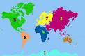 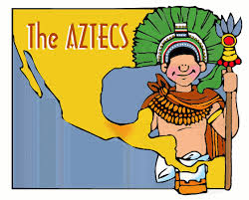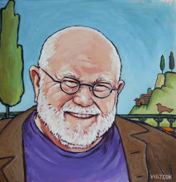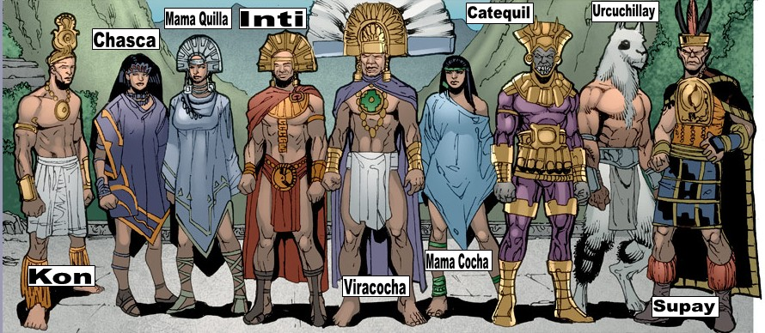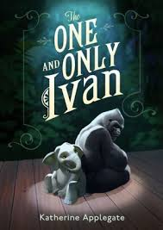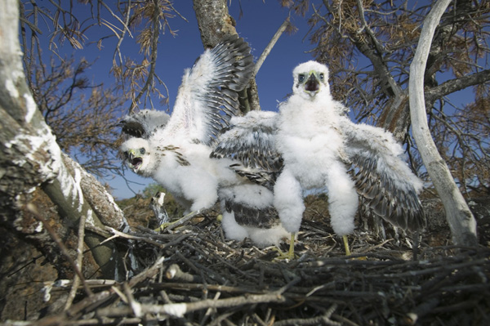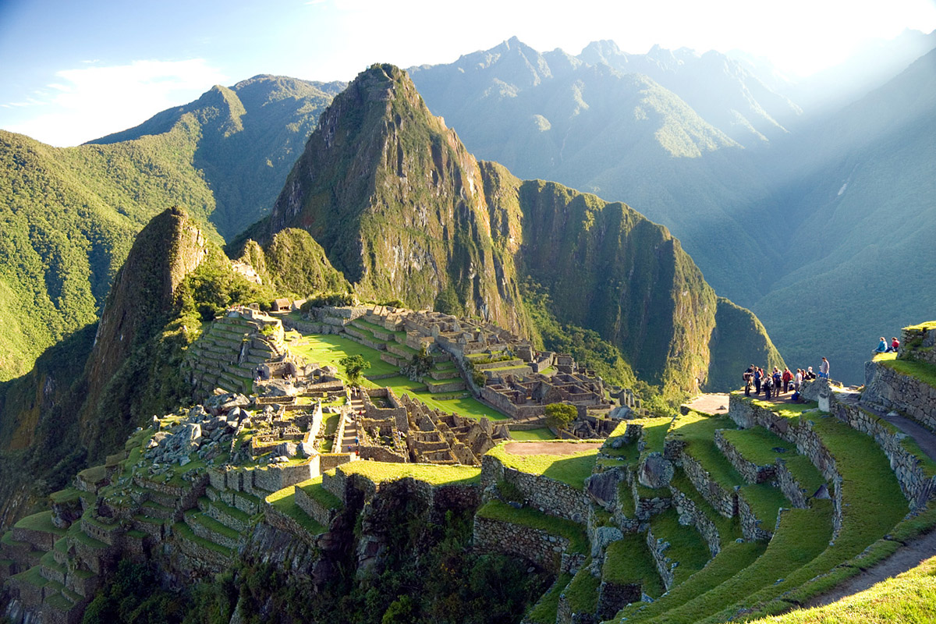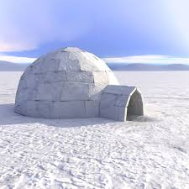****

**4th Grade GT**

O.M. State by Isabella



For O.M. at state we are going to stay the night at B.B FUN! State finals will determine if u go to World or not. State is a little harder because the judges are looking for good teams because we won at regionals so they know we are good. State is very exciting because you are going against more people. Than you did at regionals. My team has the problem of 3 and that is what we have to study. That is what state is about.

In softball I play for NEA Crush. We are raising money for softball. So we have to go and ask people if they want to buy Chick Fila. Thursday we have to work there. I think it will be really fun. SO there is coach pitch, machine pitch, and live pitch. I am in live pitch. We practice every Tuesday, Thursday, and Saturday. I am so glad I am in softball!



Softball By Anna L.

**The Aztec’s**

**We have been studying the North American Continent and South American Continents in GT. I am most interested in the Aztecs because of their culture. One thing we learned about their culture that is upsetting, is that they sacrificed people because they believed if they didn’t the sun wouldn’t come up. Did you know that they believed in many Gods? From the 13 century, the Aztecs lived where the Valley Of Mexico is, I find that very interesting.**

Geography, culture, mapping skills and

The Elementary Identified GT Students have been studying the North American and South American Continents during this Second semester

Spring GT Newsletter

4th Grade GT

BOOK CLUB BY Kay Kay

One of my events during school is book club. The members are: Anna l., Jaecie B., Ethan S., Isabella D., London W., Drew O., and myself. The book we have already read was “One and Only Ivan.” I really like book-club because we make really cool projects, for example; we made characters out of clay from the book and afterwards we got to color them. Another reason is because we all work as a team to help each other. I’m very thankful Mrs. Brown chose me out of only seven people in such a great book club!

Tommie De Paola Legends By Anna R.

Tommie De Paola is an American writer and illustrator who has created more than 200 children’s books! He writes and illustrates all kinds of books like non-fiction, fiction, and folk tales. One of the most famous books of Tommie De Paola is, ‘’Strega Nona’’, which is my favorite book he has written! I think Tommie de Paola is an extraordinary author and I will always read his books forever!

Snow in the spring

By London

This year in 2014, It snowed almost a foot in early March! It snowed so much some people couldn’t get out of their house. Kids up and down the streets played and played until they were numb to the bones.

This massive snow wipeout damaged some power lines and some families didn’t have power.

This was fun and dangerous at the same time. I chose this because I enjoyed all of this fun. Thanks for listening to this snow storm of information. Bye!

**Incas By Garner**

The Incas believed in many gods. Supay was the Inca god of death. Every time a girl was born they would sacrifice it. Some times they would sacrifice a boy. There was a law in the Inca Empire that said they could only have two children. The boys would either have to serve the king or be warriors. The girls that were not killed had to work at home or work for the king. 60% of the boys chose to be warriors. 80% of the girls chose to work for the king.



**4th Grade GT**

The Interview Process By: Drew

G.T. we are learning how to Interview. We have interviewed a lady from Mexico. We wanted to learn where she is from and we found out that she is from Guadalajara, Jalisco. That is a large city in Mexico. We interviewed her in the G.T classroom. Interviewing is where you meet a person and you ask questions to find out about their life experience. It is important to construct your questions before you interview. That way you find out what you need to know. We learned that when writing questions it is important to brainstorm, keep questions simple and clear. Also, don’t ask double whammy questions because they are too complicated to answer and can make your guest uncomfortable. Another thing is, don’t just ask filler questions. Make sure they are important enough for their time and will interest the reader.

O.M. Regional’s

By: Zoey

Our O.M. Trumann teams made it all the way to state but the day at regionals was one crazy, chaotic day!!! I’m going to share with you the TIS teams’ experience!! The night before the BIG DAY we had a performance at the Cedar Park Elementary gymnasium and all the O.M. girls had a sleepover. We all woke up bright and early and hopped on the bus! Once we got there we unloaded the prop truck and since we had time we went to the playground. When it was time for spontaneous Isabella and P.J. sat down and we went in nervously. After we completed spontaneous we got ready for competition. My costume had a “Pencil skirt” and heels SO IT WAS REALLY HARD TO WALK AROUND!!!!!!!!! Once we walked through the doors we started our performance and when we were done the judges reviewed us

And looked at our stuff and asked us questions. At the awards ceremony we were so nervous but we got 2nd place that means we get to advance to state!!! If you would like to know more about the state competition look at Isabella’s article on state!!!

**4th Grade GT**

Why I’ve picked Niagara Falls. I picked Niagara Falls, as my topic to write about because it is one of the things we have been learning about in are North America study. Where is Niagara Falls? Niagara Falls is at the border of America and Canada.

Until our study, I didn’t know Hawaii was a state. Also I now know that Pearl Harbor was attacked by the Japanese on Dec. 7,1941 World War 2. Also, there is more than one island. The eight main islets are as follows: Hawaii, Kahoolawe, Maui, Lanai, Molokai, Oahu, Kauai, Niihau. Overall the Hawaiian Islands are very beautiful places with amazing beaches and scenery. I would like to visit there one day when I’m grown.

### Niagara Falls by Ethan

**Machu Picchu: By Raven**

Machu Picchu was a place for Pachacuti and his royal court, or panaca, to relax, hunt, and entertain guests. **Sacred Landscape☺ Machu Picchu occupied a special place in the "sacred landscape" of the Inca. For example, Machu Picchu is built atop a mountain that is almost completely encircled by the Urubamba River, which the Inca named the Vilcamayo, or Sacred River. Reinhard also pointed out that the rising and setting of the sun, which is an Incan God, when seen from certain locations within Machu Picchu aligns neatly with religiously significant mountains during solstices and equinoxes.**

**Royal Feast of the Sun☺ Intimachay is a special cave designed to celebrate and observe the Royal Feast of the Sun. This festival was only to be celebrated by nobility in the Incan month of Capac Raymi and was associated with the December solstice. The festival would begin earlier in the month and would conclude on the solstice. On this day, boys of nobility would be initiated into manhood by conducting an ear-piercing ritual as they watched the sun rise from within the cave**

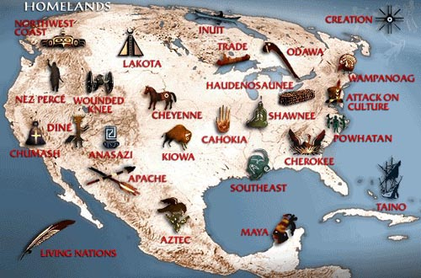

North American Indians

We have been studying North and South American continents in GT, here are some of the things I’ve learned. Groups of native people lived on the North American continent long before European explorers discovered them. They often associated together by their common language and culture. These natives have been known as Indians, American Indians, Native Americans, the native tribes of North America, and other similar terms. I also chose this topic because I am part Cherokee and I have wanted to learn more and understand more about my family history.

Ipsum a volutpat ornare, metus sem tincidunt magna, eu varius enim dolor id sem.

#### **INUIT’S by Maddox**

#### **The Inuit’s have many names such as Eskimo. but that is insulting to them so don’t call them that because they could get mad.**

#### **They used to live in igloos and they had a lot of fur to make clothes from left over food.**

People In this part of Mexico worship the Lord, prince of peace, King of kings.

Guadalajara Peoples religion by Chloe

**Hawaii by Tyler**

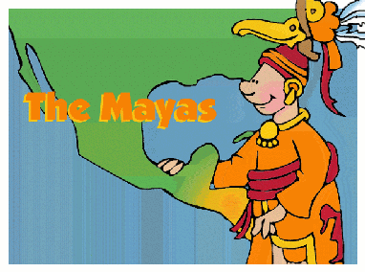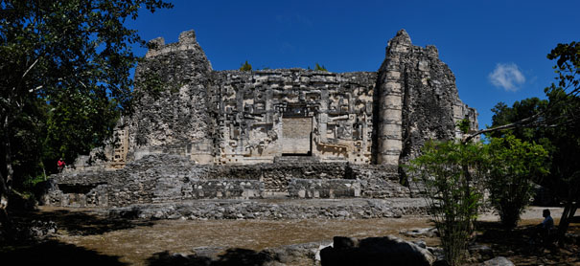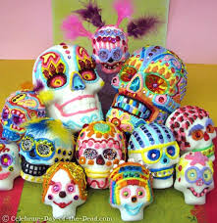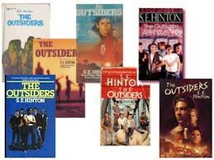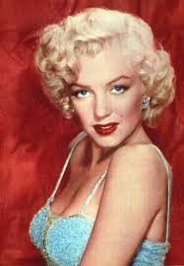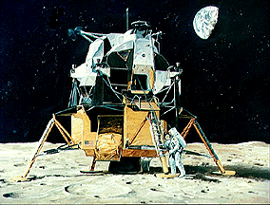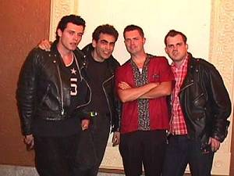**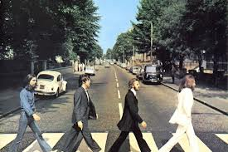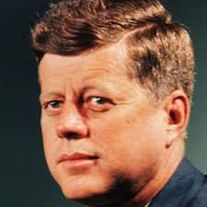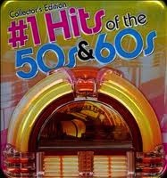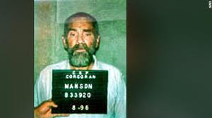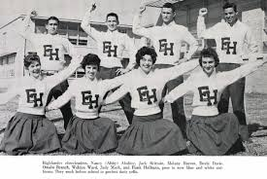

**3rd and 4th Grade GT**

Haiti

**This title I choose because has a lot of good information and because it interests me. Haiti** is a small island near Mexico & North America. There is small village’s full of many people. Haiti has it has lot of wildlife.

By Evan

Ha iti is not a good place to visit. Haiti has very nice flowers. Haiti is maybe it is stinkey.



This is just a little bit of Costa Rica nature and culture, I like Costa Rica because Costa Rica’s culture is really cool and there animals are really awesome and a lot of people like to exercise and ride horses, Costa Rica is one of my favorite paces in the world, Costa Rica is famous for all it’s beaches all of it’s beaches are really pretty, Costa Rica has a lot of people who live there, Costa Rica is one of the prettiest places in the world in my opinion. By Parks



Some Mayan Ruins

We have been studying the North American Continents and the South American Continents in GT. I am most interested in the Mayan because of their temples. The Mayan temples were built in their royalty. The first temples of the Maya arose more than 2,000 years ago. Each Mayan temple might have served a different god.

MAYANS by Michael

*Mauris laoreet elit sed dolor.*

issue, date

lorem ipsum dolor

**3rd Grade GT**

Hi I’m Landon I will tell you about Day of the Dead. Day of the Dead is a Mexican tradition and a good holiday. They make treats and decorations. They go to the graveyard to celebrate. I picked this because I like Day of the Dead and it’s resembled to Halloween and it’s a good tradition. They cook the person’s that died favorite food. Then go to the grave and eat the meal while they remember and celebrate their life. It’s a way of showing they are not forgotten.



Hi, My name is Kenzie and I am going to tell you about Carnival in Brazil. Carnival this year was on the date February 24 – March 4. They believe that they can do what ever they want and God will forgive them for it on Ash Wednesday. They have big parades and dress up in CRAZY costumes. There are 4 different kinds of parades. One of them are Samba Schools in the special group. Another one is Champion Parade. Also Samba Schools in access group and the fourth one is Children’s Samba School. The reason I chose this topic is because I love all the Crazy costumes and parades.

**3rd Grade GT**

Amazon rainforest

By Autumn

Today almost all of our Rainforests is cut down! The Amazon Rainforest is one of few rainforests that has not been cut down. Thousands of animals live there and some has not been discovered yet! Please help the rainforest by recycling and you can make a club to start cleaning up parks.

Fun Fact

Did you know that rainforests have four layers? They are the Emergent, Canopy, Understory, and Forest Floor.

MORE FACTS FOR YOU

I picked the Amazon Rainforest because I am concerned about Trees and Rainforests being cut down. The biggest rainforest is the Amazon. It is the biggest in the world.10 percent of the world’s animals is in the Amazon Rainforest.



The Outsiders, A Book Review

By Madison

The Outsiders by S.E. Hinton is her most popular book that she wrote when she was 15 years old. It is a story about a group of greasers named Ponyboy, Sodapop, Darry, Dally, Johnny, Two-Bit, and Steve. I chose this topic because I personally fell in love with the book because I made connections with my own society, the Greasers and the Socials that didn’t get along at all. I feel that the greasers are my group of friends in a way. Anyways, it is an amazing book that everyone should read.

**Who Was Yuri Gagarin?**

By Trey

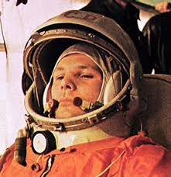

We have been studying the Fifties and Sixties decades in GT this year. The things that have interested me the most about these studies have to do with the Space Race! For example, this guy Yuri Gagarin. Did you know he was the first person in space, which put the Soviet Union in the lead for the space race! He went up into space on *Vostok 1* on April 12, 1961 from the Baikonur Cosmodrome in the desert steppe of Kazakhstan. After entering space, Gagarin completed a signal orbit around the earth. At the end of the orbit, *Vostok 1* reentered the Earth’s atmosphere. When the *Vostok 1* was about 4.35 miles above the ground, Gagarin ejected from the spacecraft and used a parachute to land safely. From launch (at 9:07 a.m.) to *Vostok 1* touch down on the ground (10:55 a.m.) was 108 minutes, a number often used to describe the mission.

***8th grade GT***

Making Up Snow Days

By Paige

Our school district has missed 12 days due to snow and ice. Our last day of school was delayed over two weeks. The Benchmark Tests are soon, and even though our learning was delayed, the tests aren’t. The second semester tests will be on the last three days, regardless of when those days are. Our school asked for a waiver from the state to waive two days that we missed. Only two days were applied for because we could only get days excused that were over 10. We got the waiver, so our last day of school is currently June 4th. I choose this topic because it’s been on all our minds and I am interested in the profession of education so there’s the connection.

**Designer Baby Procedure By Lauren**



“I want my baby boy to have eyes as blue as the summer sun and have no chance of diabetes” and “I want my baby girl to look just like Barbie and have no chance of breast cancer!”

Soon people all over will be picking and choosing just what their little miracle will look like. Many people say it’s not much different than saying they want a cheeseburger with mayo and ketchup. Well, others (including me) agree that our actual creator, God, should have the only hand in creating us. During this procedure the so-called, “parents” have to dish out $18,000. If your wondering why I quoted “parents” it’s because there is more than one parent involved. Sounds pretty “normal” right? No I left out the fact that there are three parents involved. Imagine walking in from school “ Hi Mom, hi dad, and oh yeah hi mom!” It’s pretty NOT normal if you ask me. Some logical minds are afraid of what the out come will bring, little terrors or the most adorable being ever? Back in October our 6th grade G.T. group discussed Mary Shelly’s book “Frankenstein” which has helped me make the connection with the book as she enhances the fact we shouldn’t play with nature. She basically is saying let nature be as it is. Well to conclude what side will you take? Have I convinced you enough or do you need to go back and read the paragraph?

Smoking Analogy by A.J.

Smoking is to health

As

Cavities are to a lovely smile

**Logan’s Smoking Analogy**

**Chronic use of drugs (including smoking) and alcohol**

**Is like**

**Habitually crossing your eyes when you get behind the wheel of a car**

6th grade Missing work: Drake, Walton twins and Jonah (article and analogy)

Marilyn Monroe

By Jenny W.

“Norma Jeane Mortenson” was born in Los Angeles in 1926. She married and got a job at an airline factory, when her husband was sent to the Pacific with the Merchant Marine. In 1945 a photographer took a snapshot of her at a factory. And the stunning brunette quickly became a successful model. Studio executives, directors and photographers immediately recognized her ability to capture and hold the attention of anyone on the opposite end of a camera lens. By the end of 1946 her hair had become a shade of blonde and her name was changed to Marilyn Monroe.

Marilyn became a very successful American actress, model, and singer. I chose to write about Marilyn Monroe, because to me Marilyn Monroe was a great inspiration to women, she showed you don’t have to be a size zero to fit in. Marilyn Monroe quote: “To all the girls that think you’re ugly because you’re not a size zero, you’re the beautiful one. It’s society who’s ugly.” In 1962 Marilyn Monroe bought her first home in Brentwood and began decorating it with purchases from a trip she had made to Mexico. She died that same year in her new home under controversial circumstances. Regardless, Marilyn Monroe’s personal history, achievements and contributions have made her one of the world’s greatest icons.

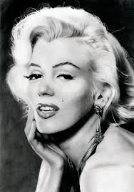

John F. Kennedy

By Drake

On the day of November 22, 1963 arguably one of America’s most beloved presidents was shot. It happened in Dealey Plaza in Dallas, Texas. The suspected murderer was Lee Harvey Oswald. A man named Jack Ruby killed Harvey during a police transfer two days after the shooting. It is believed that Harvey shot JFK from the Texas School Book Depository. It is still argued over where and who the killer actually was. It is also known as one of the most tragic events in American history. One thing is for certain that this incident will never be forgotton. I chose this topic because I really like history and watch the history channel all the time. I think this event is a very major part of the history of the 60s in the United States.

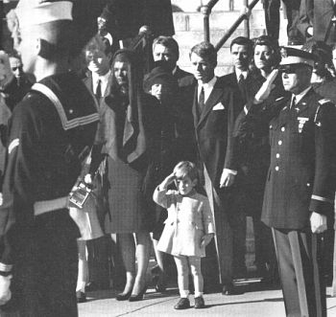

*This is one of the most iconic and known photo from*

*the incident it shows Kennedy’s son saluting the flag at his father’s funeral.*

Analogy

By Jonah H.

Smoking is to lungs as a virus is to a computer

Jenny’s Analogy

Drinking is to an Alcoholic,

As milk is to a newborn baby.

APOLLO 11 MOON LANDING

JACKSON

Apollo 11 was the first spacecraft that landed the first humans on the moon. On July 20, 1969 the spacecraft took flight on its way to the moon. The crew: Neil Armstrong, Commander; Michael Collins Command, module pilot; Edwin Aldrin Lunar module pilot. They were on the surface for 21 hours 38 minutes 21 seconds. Did you know that the original Neil Armstrong footprint is still on the moon? This is due to the moon having no atmosphere. I think that learning about the first moon landing is a good educational opportunity, I am really interested in this subject because I like science! I plan on perusing a career in the science field or in law.

Analogy

By: Jackson Smoking is to lung cancer as a cook is to food.

The Six Days of War

I picked this topic because it stood out from the other topics. When I started reading about the sixty-day war, it was very interesting. The sixty-day war took place in June 1967. The war was fought between June 5th and June 10th. General Moshe Dayan, the Israeli’s Defense Minister, initiated the war. The war was against Syria, Jordan, and Egypt. Israel believed that it was only a matter of time before the three Arab states coordinated on a massive attack on Israel. After the 1956 Suez Crisis, the United Nations has established a presence in the Middle East, especially in the sensitive border areas. Just like the title the war lasted sixty-days.

Cierra’s Smoking Analogy

Smoking can cause bad breath as like not brushing your teeth.

Martin Luther King Jr. Assassinated! By Logan

In GT we have been learning about the sixties era. I chose to focus on Dr. Martin Luther King Jr. because I was interested in learning how he died. I know that he had a very big famous speech but I haven’t heard that much about how he died. I know he was assassinated but how and why did they assassinate him? Here is what I found out.

On April 4th, 1968 at exactly 6:01 Martin was shot right here in Memphis TN (which is so close to where we live it blows my mind) with a .30-caliber rifle bullet while he was standing on the hotel balcony. That went straight through his check, through his neck and finally stop at his shoulder blade. At exactly 7:05 Martin was claimed dead. The murderer James Earl Ray was claimed a racist and small-time criminal.

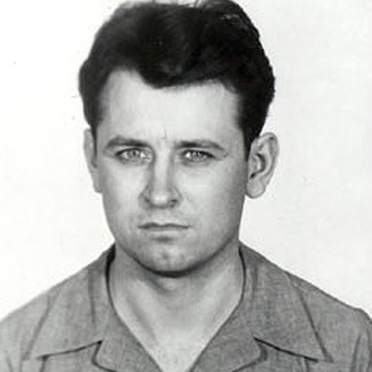 -James Earl Ray

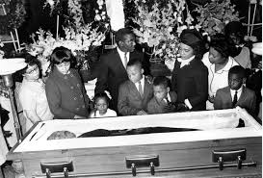 -Martin Luther King

6th grade GT students

Lauren’s Smoking Analogy

Smoking serves up gum disease

As

A truck stop waitress serves up French toast!

Smoking Analogy by Jose

Puffing on a cigarette is

As

Making an own goal in soccer

**Looney Tunes** 

By Jose

I chose Looney Tunes to write about, because I still watch it to this day. I also appreciate the creativity of the stories and action. When I was young I watched it all the time with my mom and dad. Did you know that at the beginning Tweedy Bird was pink and name was Orson and play on the show A *Tale of Two Kitties. Also, this series began in the 50’s and continued in popularity throughout the 70’s.* Marvin the Martian’s dog name is “Captain K-9.” My favorite is Daffy Duck & the Tasmanian Devil.

Escape From Alcatraz

By Jonah

John and Clarence Anglin preformed this escape on June 11th, 1962 accompanied by Allen West and Frank Morris. They chiseled their way through the vents of the cells and running through an unused corridor. Next they climbed a ventilation shaft to the roof then climbed off of the building from there, they then scaled the fence of the courtyard. They then formed a raft out of cement and raincoats. After 17 years of investigation the found that they drowned in the waters on there way there. I choose to research this topic because it interested me, because these men were (almost) successful in escaping such a maximum-security prison on lock down.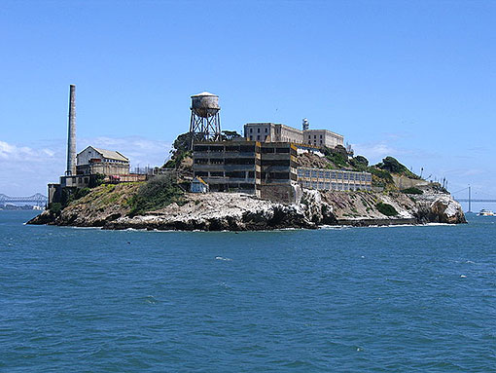

**Smoking Analogy By: Lauren**

**Smoking is harmful to the Lungs**

**As**

**Pollution is harmful to Earth**

Smoking Analogy

Ashtray breath is to attractive,

As

Glamor is to the city dump.

The Outsiders Novel

Summary

By: A.J.

*Famous children’s author S.E Hinton wrote the bestseller, The Outsiders. This novel is about a 16-year old greaser named Pony Boy. A greaser is a young man who is in a gang. Pony Boy and his brother, Dairy’s gang are trying to struggle through life, while competing with the wealthy gangs called the Soc’s. This gang attacks the greasers often. They even traumatized Pony Boy’s best friend, Johnny. Repeatedly throughout this enthralling book, Pony uses a method, often seen in the study of literacy, named metacognition. This means to think about your own thinking and this is a higher order thinking skill we have discussed often in GT. I liked this book because it gave me a chance to see what life was like during the late 50’s, early 60’s, which is what we studied this year!*

**

6th grade GT students

Cheers Unlimited Competitive Cheer

For 4 years I’ve done competitive cheerleading!!

It is amazingly fun and it keeps you fit and healthy. First, I went to ACC (Arkansas Cheer Company which is where my friend Jacie cheers. Unfortunately, I only went there for about 5 months.

Then, I went to CTR (Cheer Time Revolution) for about 3 years. Our team colors were orange and black. I was on the mini team because I was only 7. We won a lot of 1st place trophies!! Lastly, I went to CU (Cheers Unlimited). This was the last company I have cheered at so far. I still cheer there now, this is my 2nd year cheering there. This year has been very successful!! My last competition was in Nashville, we got 1st place!!

**I love cheer! By Mia**

Zodiac Killer

By Samuel

The zodiac killer was a serial killer in the 1960s and 70s. His case was never solved and is still open. He had a symbol, a cross and circle. He sent letters to the SFPD with ciphers, and one has never been cracked. He killed his victims either by stabbing them to death or shooting them repedeatly. There were only 2 survivors of over 35 murders and disappearances.

Let It Be The Beatles By Caidyn

Do you like music? I do, the Beatles are my favorite band. Everyone in the band started in a solo career but August 17th 1960, they played their first gig together. They played over 30 gigs a month. Brian Epstein (a reporter) wrote about them in *Mersey Beat* where they got on the front cover. June 1962 they recorded “Love Me Do”. November 1962 The Beatles record “Please, Please Me”. Producer George Martin thinks will be a big hit. They wrote so many song including; A Hard Day’s Night, From Me To You, Let It Be, Yellow Submarine, I Want To Hold Your Hand, and more (I just can’t remember all of them). I still listen to them in the car. They’ve come a long way.

My analogy

By Samuel

Drugs and Alcohol are to health

As Kryptonite is to Superman

Journey’s Smoking Analogy

Smoking is to lung cancer

As

A lottery ticket is to losing your money

1969 Sesame Street Is First Aired!

By Journey

On November 10, 1969 there was changing of kids living with having to play with board games now they will only care about one thing, *Sesame Street!!!* My favorite character consists of Kermit. *Sesame Street* was and still is an amazing show today, and it doesn’t matter how old you are because I am eleven and still watch it! *Sesame Street* has funny characters the characters are Kermit the Frog, Cookie Monster, Bert and Ernie, Elmo, and of course Big Bird! The Muppets work together to solve problems & learn. The Muppets were almost like my family because I grew up watching *Sesame Street* & it’s such a good television show!!

My smoking analogy

Smoking is to terrible

As the 1960’s are to fascinating

Smoking Analogy By Caidyn

Smoking is to Healthy

As

Little Brothers are to Quiet.

Toys & board games in the 60’s

by Luther

* After my search I learned that in 1960 the game LIFE was made. The sketch-o-matic & the super ball were in the 60’s as well as play-doh. Also the bear top was in the 60. The rock’em sock’em robot’s were made in the 60’s. So was twister and clue. The reason that I chose this topic is because I like games. So I wondered what games were popular in the 60’s and my dad told me about some of the toys he played with in the 60’s. Yet, I wanted to know more. That’s why I chose this topic to research. They still have the rock’em sock’em robot’s in Wal-Mart.

Smoking is to the body as pollution is to the world. Smoking Analogy by Luther

Logan’s 60’s Analogy

Nixon is to the Big Bad Wolf

AS

Villain’s are to unpopularity

Hannah’s Analogy

Smoking is to Cancer

As

Cause is to Effect

Journey’s Analogy

Smoking is to Cancer

As

Slugs are to slim.



Let the Beatles Become

By Hannah

The Beatles first had to form a band to get famous. John and Paul first ever met on July 6, 1957 at a fair. John was only 16 and had already formed a band called the Quarry Men who were going to perform at the fair. Many friends introduced Paul after they played, and Paul just turned 15. After they introduced Paul he wowed John with his amazing guitar skills. After a week Paul joined the band. A year later (1958) John, Paul, and George still needed a bass guitar and a drum player. However a year later (1959) art student Stu Sutcliffe filled the spot of the bass guitar player. Then in (1960) Pete best that was good with the girls joined as a drummer. Then they had the whole band.

The Beatles signed a record deal in the fall of 1961. And they set off to America to get famous. They had a one hit and they made it. The Beatles 5,000 screaming fans when they arrived to the airport. Then they became famous till they broke apart. The reason why I chose the Beatles is because they inspired me to love all kinds of music even theirs.

John F. Kennedy

By Jordan

I know there are a lot of different thereabouts of the assignation of John f. Kennedy. Here is how I believe it has happened. On the day November 22, 1963 he was shot in his vehicle at Dallas Texas. He was the youngest elected president and the youngest to die. Some people say that there were more than one shooter I think that there was two assassins, one from the front and a shooter from the back. Also, there was one that shot the person in the passenger seat and the president. That is how I think JFK was assonated.



Jenny’s 60’s Analogy

Nixon is to tape recorders

As

Thieves are to security cameras

Jonah

Nixon is to getting caught as

Pinocchio’s nose is to growing.

Drake 60’s Analogy

Nixon is to Watergate

As Hitler is to the Holocaust

Jose’s 60’s Analogy

Nixon is to corruption

As

A rusty steel pipe is to salt water.

#LeBron Meets Ebony

By: Emma

In February, the hashtag #LeBronMeetEbony trended on Twitter thanks to a high school basketball team from Verona, WI. They were trying to set up a meeting between their teammate, 16-year-old Ebony Nettles-Bey, who is battling lung cancer, and her hero, LeBron James.

A little more than a month later, on Saturday night, Ebony's dream came true. According to Madison.com Ebony thought she was just going to watch the Miami Heat play the Milwaukee Bucks. But then, a Bucks representative led her to the Heat's locker room. She then ran onto the floor with the team, practiced with LeBron and stood by him during the national anthem.

Back when the hashtag gained steam on Twitter, ESPN’S Rick Reilly wrote a letter to LeBron listing the similarities between him and his young fan: They both wear headbands, they're both awesome at basketball, Ebony hopes to go pro someday and she also hates to lose.

But in a press interview following their Saturday night hangout, LeBron pointed out one thing he feels makes her different: "She's the stronger one out of us two... she's unbelievable," he said.

I chose to write about this because I’m interested in technology and we have been talking about the negative effects of smoking. So a connection I thought of is that Ebony could have gotten her lung cancer by second hand smoke.



Cars Of The 60’s

The cars of the sixty’s included Ford and Chevrolet as the biggest car company’s of the sixty’s. Ford had the Shelby Cobra as their top car in the time period and Chevy had a corvette as Stingray as their top car in the time period. The ford was, and still is a classic car. The corvette Stingray was a Classic car and still is like the ford. They both were fast and luxury cars. 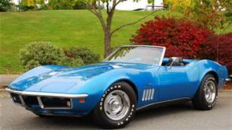

They both made reruns of each cars like ford made the Ford Shelby Cobra GT500 and Chevy made the Stingray. The Ford Shelby Cobra was made in 1950. Then the Corvette Stingray was made in 1953. The reason that I wrote this is because I like cars.

Smoking is to lungs

As a car is to a popped tire



Music in the 1960’s

By Caroline

Before 1963, the music of the sixties still reflected the sound, style and beliefs of the previous decade. Many of the hit records were by artists who had found typical success in the 1950s, like Elvis Presley, Ray Charles, Dion, and The Everly Brothers in 1963 and, the years that followed.

Sixties rock finds its roots in several places, starting as far back as the big swing bands of the pre-war era that the 60’s kids parents listened to as the youngsters: Glenn Miller, Benny Goodman, Count Basie, Tommy and Jimmy Dorsey, and Duke Ellington’s bands are some of the famous of the most famous music artists. Except for Duke Ellington, all of those bands were primarily dance bands, with big swinging backbeats. You can still hear some of their greatest hits today in such unusual places as the Chips Ahoy commercial (1,000 chips in every bag).

There were also the smaller, “rhythm combo” groups, usually of only four or five players. Their tunes were popular on the jukeboxes of the day, but were not considered artistically important which is why we have mostly forgotten them today. The recent Broadway show, “Five Guys Named Moe,” which highlights the career of Louis Jordan, tells about one of the most popular rhythm combos of the day. Nat King Cole also had a Small jazz combo that had a popular success, before he became a Sinatra-style pop ballad singer in the 50’s.

**A.J.’s Analogy on the 60’s**

**The Vietnam War is to the Korean War**

**As**

**Words are to their synonyms**

Doctor Who

By Maci E

Like science fiction British TV shows about time-travelling humanoids? Then you’ll love Doctor Who! Doctor Who first aired in November 23, 1963. The main character in this series was a Time Lord named Doctor Who. The show has a series of enemies, such as the Weeping Angels and Daleks. Also in the set of 12 doctors, each had a companion who travels with, or shares the adventures of the Doctor. I chose this topic because I like to watch science fiction shows.

Smoking is to caner

As

A cheerleader is to pompoms

By Jacie

The Manson Family Murders By Teri

On a hot muggy Saturday night during August 9th, 1969

A young movie star, Sharon Tate, was at her home and her husband was director Roman Polanski and he was in Europe.

Sharon was eight months pregnant at the time and she had her friends Abigail Folger and her boyfriend plus and internationally known hair dresser Jay Sebring.

That night the Kotts, Sharon's nearest neighbors who lived about 100 yards away, thought they heard a few gunshots coming from the direction of Sharon's property sometime between 12:30 and 1 A.M. But since they heard nothing else, they went to bed.

A private security guard hired by some of the wealthy property owners thought he heard several gunshots a little after 4 A.M. and called his headquarters. Headquarters, in turn, called Los Angeles Police Department to report the disturbance. The LAPD officer said: "I hope we don't have a murder; we just had a woman-screaming call in that area."

The housekeeper found blood spots in the house and a white Rambler outside, a body on the lawn, and a body in the car the house keeper ran to house to hose trying to get someone’s attention.

The killer was Charles Manson and some people he hired

My analogy

By Teri hill

Nicotine is to cigarettes as chlorine is to a pool

:



Cheerleading

By Jacie

In the 60’s you could find cheerleading in every high school and grade school across the county. Peewee cheer and youth cheer was focused on more, so smaller grades girls could cheer. In 1965 Fred Gastoff was the first to make vinyl pompoms and the International Cheerleading Foundation, which is now know as WCA (World Cheer Association). Professional football teams began to see that cheerleading was part of entertainment package. Though the Baltimore Colts was the first Professional football team to have cheerleaders, but Dallas Cowboys was the achieved mass popularity professional pro football team.

International Cheerleading Foundation began to rank the best collage cheerleading squads. So as you can see that cheerleading was big in the 60;s and a lot of stuff related to cheer. I wrote about this topic because I’m currently involved in cheerleading and love the athletics involved in this sport.

My Drinking Analogy

By P.J.

An alcoholic is to a bar

As

A baseball is to a bat.

A smoker is to a cigarette by Madison

As

The Beatles are to the Yellow Submarine

Analogy

By Paige R.

The old church is to The Outsiders just as smoking is to us – deadly, harmful, and hard to escape from.

The old church is to The Outsiders just as smoking is to us – deadly, harmful, and hard to escape from.

Final Four

By: Cole

The NCAA men’s final four is a playoff tournament in college basketball. It contains the top four teams in college basketball that have battled out five rounds to get where they are now the final four this year in Florida, Wisconsin, Kentucky, and Connecticut. The finals this year is in Dallas, Texas at the AT & T stadium. It will all go down on Saturday April 5 as they play each other on the court.

Smoking analogy

Tar is to cigarette as rain is to clouds



Smoking analogy

By: Whitney

Smokers are to cigarettes

As

Peanut butter is to jelly

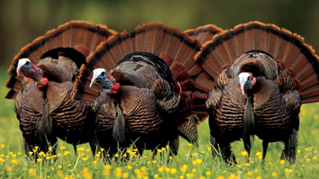the sport of Turkey hunting

by rives

Once you locate a gobbler, the next step is to move in close and call him into gun range. Your goal is to slip as close as possible without spooking him. Then you “set up” and attempt to call him close enough for a shot. Remember: when approaching a turkey, if he spots you, he’s gone! Be careful not to be seen. Terrain and foliage normally dictate how close you can get before setting up. Veteran hunters rarely approach inside 100 yards. They may set up as far away as 300 yards if the ground is flat and there is little foliage to conceal their movements.

Use the terrain to your advantage as you approach a gobbler. Stay behind hills, thickets or other features that will screen your movements. Walk as quietly as possible in the leaves, and don’t break any sticks. When setting up, pick a location that offers the gobbler an easy route to your location. There should be no creeks, gullies, fences, thick undergrowth or other barriers between you and the bird. Also choose a spot that is on the same contour or slightly above the turkey’s location. Don’t try to call a gobbler down a steep slope. Pick an area that provides you with a good view of your surroundings.

Analogy

A smoker is to cigarettes

As

A turkey is to gobbling

Offseason Volleyball

Offseason Volleyball hasn’t been a struggle but it hasn’t been too easy. On Tuesday and Thursday we workout in the workout room and on Monday, Wednesday, and Friday we work on setting, serving, passing, and hitting when we are not working out. The seventh grade has gotten three new members. We have also learned a new drill The Half Butterfly. Next season will be a success.

By Adri and Jada

Star Trek Original T.V. Series

By Spencer

We have been learning about the 50’s and 60’s in GT this year. I like star track, so I chose to write on this topic because the series was produced 1966–67 by Desilu Productions, and by Paramount Television 1968–69. *Star Trek* aired on NBC from September 8, 1966 to June 3, 1969.[[2]](http://en.wikipedia.org/wiki/Star_Trek:_The_Original_Series#cite_note-2) Although this television series had the title of *Star Trek*, it later acquired the retronym <http://en.wikipedia.org/wiki/Retronym>of ***Star Trek: The Original Series*** (***Star Trek: TOS*** or ***TOS***) to distinguish the show within the media franchise that it began. *Star Trek*'s Nielsen ratings while on NBC were low, and the network canceled it after three seasons and 79 episodes. Nevertheless, the show had a major influence on popular culture and it became a cult classic in broadcast syndication during the 1970s. The show eventually spawned a franchise, consisting of five additional television series, 12 theatrical films, numerous books, games, toys, and is now considered one of the most popular science fiction television shows of all time.

Analogy

Smoking is to lungs as water is to fire.

Zodiac The killer

By Katie

The reason I chose this topic is that I like mystery and this is a big one. I’ve always wanted to be a police officer. It’s fun to think about all the mystery.

The police had over 2,500 suspects, but the case was never solved. It was huge because this went on four 2 years. In 1966 there were a series of murders that panicked the people in San Francisco. Zodiac taunted the police for years with phone calls and text. He changed the life of eight people. Only two live to tell the story. On October 30, 1966, before any one heard of the killer he struck his first victim an 18-year-old girl named Cheri was murdered in a parking lot. 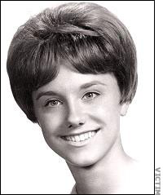

Smoking is to exercise

As

Dogs to talking

My Drinking Analogy

By P.J

An alcoholic is to a bar

As

A baseball is to a bat.

John F. Kennedy

By P.J.

John f. Kennedy was assassinated on November 22, 1963. It was devastating, because our president was assassinated and nobody could take his place. I think that we should guard our presidents more carefully.



First Woman in Space By Amare

On June 16, 1993 a soviet cosmonaut woman named Valentina Vladimirovna Tereshkova was launched into space. Valentina orbited Earth 48 times in the Vostok 6 and flight lasted 2.95 days (or 70.8 hours). Valentina was 26 on the mission. One thing that helped her become cosmonaut was her skydiving. She was in a skydiving club with her friend and was skydiving a lot. Her mother hated her skydiving because she thought it was boy like and would sometimes lock her in her room so she couldn’t go. She never returned to space but did get her doctorate in engineering in 1977.Now she is 77 and still alive.