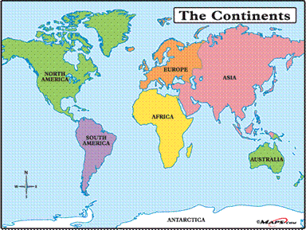

Dear Parents,
This year at the elementary level in GT we will study the continents of Australia, Europe and Africa. As you know we studied Asia, North America and South American Continents last year. My goal is to build their interests and skills in several key curricular areas: Geography (mapping skills, land forms), Social Studies (regarding respect for diverse cultures), Science (current events such as Ebola Virus and the scientist who are working toward a vaccine or medication to help more survive it), language Arts (research and writing) and Art of course (respond through art).

During our study of Australia, we will of course explore The Great Barrier Reef (the worlds largest coral reef system) that’s located off the coast of Australia.

My plan is to create (with the help of my students) a large display in the title one hallway to stimulate student interest in art, science, and literature for not only my GT students but also all of the K-2 Enrichment classes that will travel through the artistic depiction of the Barrier Reef on a weekly basis.
Here is an example of what I use to create with kindergarten students before I got this position.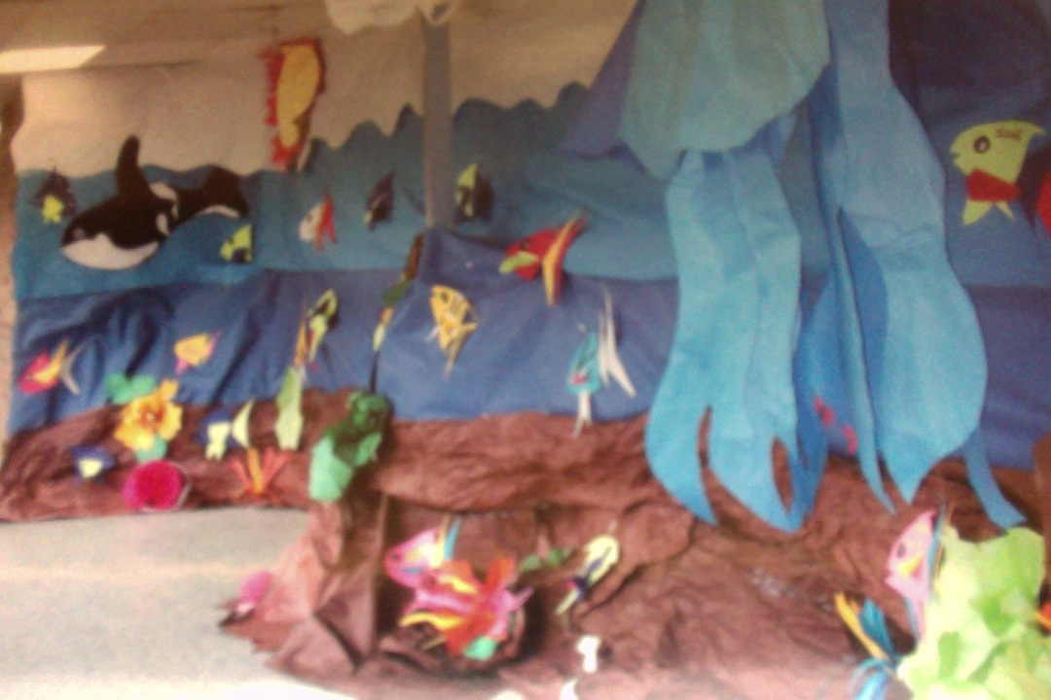
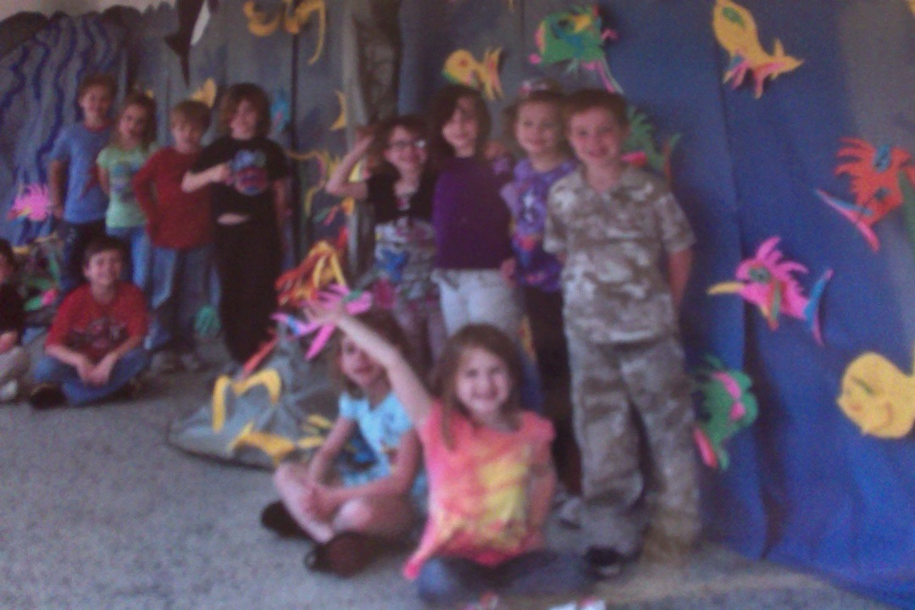
We study Broad topics in the Gifted Program to insure that the curriculum is representative of diverse interests, that’s beyond the scope of the regular classroom so that GT standards are clearly met.

GT Units of Study At the Intermediate Level 5-8
In years past, we have conducted lot’s of research and read many great literary works connected to our units of study; Shakespearian Tragedies, Great Expectations by Charles Dickens, To Kill A Mocking Bird by Harper Lee, The Outsiders by S.E. Hinton.

Units such as:
- The Renaissance (2011-12)
- Victorian Period (Dickens life/ Queen Elisabeth) 2011-12
- The Roaring 20’s (2012-13)
- The Great Depression of the 30’s (2012-13)
- Many elements about World War II and how it effected a great change on the American culture, this was so we could truly understand the 50’s (2013-14)
- The 50’s Rock and Roll decade (2013-14)
- The 60’s, The Vietnam War, The Cold War, which brought about even more changes in the American culture (2013-14)
- This year is the 70’s and 80’s decades of course! (2014-15)

The book we’ll read is titled My Side of the Mountain by: Jean Craighead George.

I greatly anticipate a highly stimulating, instructive school year! So, in closing if you find that you have any questions regarding your gifted child’s needs, please feel free to call upon me.

Sincerely,

Mrs. Kimberly Stevens
Trumann Gifted and Talented District Coordinator
870-483-5314
GT website:
http://trumannschooldistrictgtwebsite.weebly.com/
email: kimberly.stevens@trumannwildcat.com

